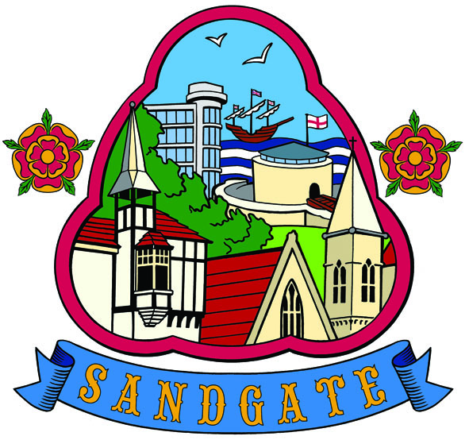

Sea Festival & Events Committee

Terms of Reference

Approved at Full Council 20th May 2024
Review May 2025

1. Purpose
The purpose of this Committee is to organise the Sea Festival and an annual programme of events, and to provide direction for officers, councilors and volunteers in the planning, organisation and evaluation of these events.

2. Membership
The Committee shall comprise of at least three Councilors appointed at the Annual Council meeting or at a Council meeting. At the first meeting of the Committee a Chair will be elected by the members and the proposed terms of reference agreed and accepted. The terms of reference must be approved by full Council. All Councillors will receive the agenda and draft minutes for each meeting.

Further, representatives of organisations and community groups in the Parish
will be invited to meetings to discuss and arrange the Sea Festival and other events.

3. Quorum
A quorum will be three members.

4. Meetings
The Committee should hold at least four meetings each year of which the dates and times will be agreed at the start of each financial year. Any further meetings required will be convened on a needs basis, determined by the Chair in conjunction with the Clerk.

5. Conditions
5.1 Due to the confidential nature of some items of business to be transacted it may on occasion be necessary to hold meetings (or parts thereof) in private in pursuance of Public Bodies (Admission to Meetings Act 1960 Section 1 as amended 2014 and by the Openness of Local Government Bodies Regulations 2014). This can be done at any point during the meeting.

5.2 Minutes are to be an agenda item and presented for noting at the next meeting of the Parish Council.

5.3 The Committee may co-opt to fill temporary vacancies.

5.4 The Committee is empowered to invite specialist professional officers or advisers to attend meetings to provide guidance as to matters under discussion. If a cost is involved this must be agreed and resolved at a Council meeting before the attendance of the officer or adviser takes place.

5.5 The Committee has powers delegated by Full Council in relation to organising the event. The powers will include planning and organising, agreeing risk assessments and the consideration of advice from the FHDC, and expenditure within an agreed budget for each event.

5.6 Only members of the Committee may vote on agenda items. Staff and representatives from other organisations will not be formal members of the Committee and will not have any voting rights on this Committee.

5.7 Non-Members of the Committee are subject to the same rules as Committee members regarding confidentiality and the requirements of the Code of Conduct.

5.8 The Committee will comply with and have due regard to Council policies and guidance, which include (but are not limited to):
- Standing Orders
- Financial Regulations.

6. Restriction
A member of the Committee must declare any conflict of interest and withdraw from the room and/or abstain from voting as appropriate.

7. The Committee’s Responsibilities and Powers
7.1 The Committee has delegated powers including to make expenditure within the relevant budget;

- Sea Festival £3500.00
- Community Events £1000.00

7.2 Urgent matters requiring expenditure will be dealt with as per the Council’s Financial Regulations.

The Terms of Reference were approved by Sandgate Parish Council at the full Council meeting on 15th May 2023

