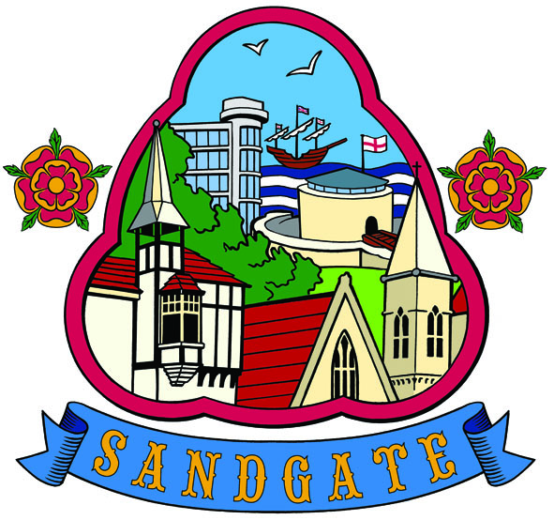

SANDGATE PARISH

FINANCE COMMITTEE MEETING
Date: 8th August 2011
Time: 14:00 pm
At
Sandgate Council and Library, Sandgate High Street

AGENDA
______________________________

- Apologies
- Declarations of interest
- Minutes of last meeting
- Budget 2011/2012
- Any other business
- Date of next meeting

