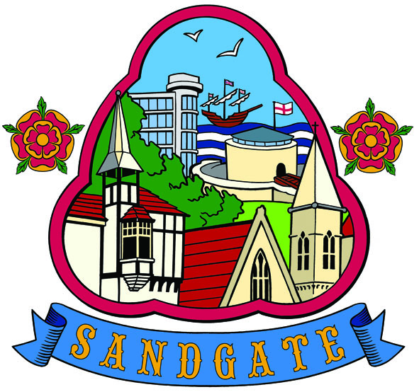`

SANDGATE PARISH COUNCIL
Minutes of PLANNING COMMITTEE MEETING
Held at 7 pm on26th April 2011
At
Sandgate Parish Council/Library Offices
James Morris Court, Sandgate High Street, Sandgate.
~~~~~~~~~~~~~~~~~~~~~~~~~~~~~~~~~~~~~~~~~~~~~~~~~~~~~~~~~~
Meeting opened at 6 30pm
Present: Chairman: Cllr A Rimmer
Cllrs: Z Varian and S Boot

1. Apologies for absence - Cllrs N Bliss and G Boot
2. Declarations of Interest - None
Councillors present should disclose personal interests in any item on this agenda. A councillor with a personal interest must describe and give details of the interest. Unless the personal interest amounts to a prejudicial interest, he/she may participate fully in the meeting.
A prejudicial interest is one, which a member of the public with knowledge of the relevant facts, would reasonably regard as so significant that it is likely to prejudice a councillor’s judgement of the public interest. Anyone with a prejudicial interest must, unless an exception applies of a dispensation granted withdraw from the meeting room.

3 Minutes of last meeting - That the minutes of 12th April 2011 having been circulated were signed as a correct record and signed by the Cllr A Rimmer

4 Planning Applications for discussion

Application No | Location | Detail | Decision
Y11/0328/SH | 18 Encombe Sandgate | Extension to time limit of planning permission Y08./0367/SH for the erection of a first floor side extension on existing balcony | Received 7 4 11  Comments by 25 4 11  No Objection x 3
Y11/0273/SH | The Mount the Riviera Sandgate Folkestone | Erection of single storey side extension (West Side) | Received 7 4 11  Comments by 25 4 11  No Objection x 3
Y11/0127/SH | 8 Temeraire Heights Sandgate | Installation of Window to side (East) elevation to the top storey | Received 11 4 11  Comments by 28 4 11  No Objection x 3

5 An update on previous planning applications. None
6. Correspondence - None
7 Date of the next Planning Meeting TBA

The meeting closed at 7 15 pm

Chairman of the Planning Committee…………………… Date………………………..2011
(or member of the Council)

