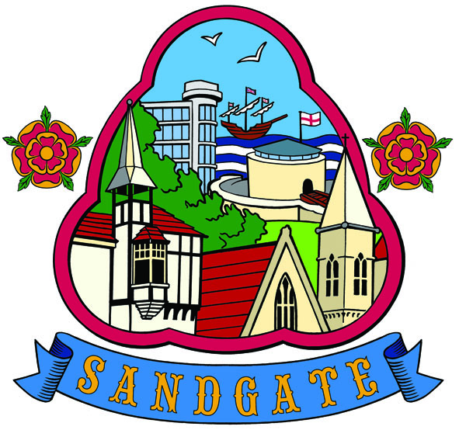
Minutes

SANDGATE PARISH COUNCIL MEETING
Date: 9th March 2010. Time: 7.00pm
Venue: Sandgate Council and Library, Sandgate High Street.
~~~~~~~~~~~~~~~~~~~~~~~~~~~~~~~~~~~~~~~~~~~~~~~~~~~~~~~~~~~~~~~~~~~~~~~~~~~~~~~~~~~~~~~~~~~~~~
Present: Chairman G Boot
Cllrs. A Rimmer, J Holben, S Boot, N Bliss, R Dixon, M Fitch and S Prater
Parish Clerk Mrs G Baker
~~~~~~~~~~~~~~~~~~~~~~~~~~~~~~~~~~~~~~~~~~~~~~~~~~~~~~~~~~~~~~~~~~~~~~~~~~~~~~~~~~~~~~~
(PCSO M Wilson had earlier circulated a report).
Public Questions Twenty minutes had been set-aside for the public to ask questions of the Council. Each member of the public wishing to put a question will inform the Parish Clerk at the time of their arrival at the meeting and questions will be put accordingly. Speakers will be allowed a maximum of two minutes to put his or her question. The Parish Council will endeavour to answer any question put to them within the time limit of two minutes, but may have to contact the questioner at a later date with an answer, or consider placing the matter on the agenda for the next meeting for a more lengthy discussion.
Questions - 1 Placing of HG Wells seat - answered by Cllr J Holben
2 Lighting problems in The Riviera - Problem emailed to KHS by the clerk.
.~~~~~~~~~~~~~~~~~~~~~~~~~~~~~~~~~~~~~~~~~~~~~~~~~~~~~~~~~~~~~~~~~~~~~~
The Chairman opened the meeting at 7.00pm. 9 members of the public attended.
1. Apologies for absence - Cllrs Z Varian, S Whiffin and J Hartman-Jemmett

2. Declarations of Interest - There were no declarations of interest.
Councillors and officers present should disclose personal interests in any item on this agenda. A councillor or officer with a personal interest must describe and give details of the interest. Unless the personal interest amounts to a prejudicial interest, he/she may participate fully in the meeting. A prejudicial interest is one which a member of the public with knowledge of the relevant facts, would reasonably regard as so significant that it is likely to prejudice a councillor’s judgement of the public interest. Anyone with a prejudicial interest must, unless an exception applies of a dispensation granted, withdraw from the meeting room.

3 Minutes of last meeting a - That the minutes of 9th February 2010 were confirmed as a correct record and signed by the Chairman. Proposed by Cllr J Holben, seconded by Cllr N Bliss and agreed unanimously
4 Chairman's opening remarks
5 Chairman's correspondence
6 Yellow lines Military Rd/Bybrook/Enbrook extra costs this was agreed and proposed by
Cllr N Bliss, seconded by Cllr A Rimmer and agreed unanimously.
7 Interreg funding Cllr J Holben informed that this would probably be of interest for the PP&DS this was a project which was match-funded by man hours time etc. Cllr J Holben would know more after attending a meeting later in the week.
8 Village sign budget the clerk was asked to contact Hythe Town Council regarding cost and makers of recent sign they had put up.
9 Parish funding for community project proposals Cllr G Boot suggested funding to be made available to local groups for projects in Sandgate. Bids for a £10,000 grant to be requested. . Proposed by Cllr N Bliss, seconded by Cllr S Prater and agreed unanimously. The clerk to ask F T C for a copy of their rules etc
10 Litter Bins update Cllr S Prater to supply a copy of a map with positions of the bins on.
11 Planters and Hanging Baskets The cost of planters and hanging baskets was quoted as being the same as last year £3,700 it was proposed the council go ahead with this, proposed by Cllr R Dixon seconded by Cllr S Boot and agreed unanimously.

12 Newsletter [JH] This will now go out in time for Easter.
13 Parish Plan + Design Statement update - The return of the questionnaire was not high enough and ways of increasing this to be discussed. There will be press releases over the next 4 weeks and a public meeting on April 28th to share first draft ideas of the Plan.
14 Beach Cleaning The next litter pick is on Saturday 13th March.
15 Recreation Ground Amenities funding (JH) Cllr J Holben was chasing funding for a MUGGER and will know more for the next council meeting.
16 Business Forum Cllr G Boot to arrange another Business Forum and invite Chris Kirkham from Discover Folkestone, Hythe and Romney Marsh to be the speaker.
17 Sandgate tourism - Cllr J Holben reported on the meeting with Chris Kirkham from Discover Folkestone, Hythe and Romney Marsh, many ideas to be followed up.
18 Library update Cllr G Boot reported the last quarterly meeting went well.
19 Children’s Creative Writing prizes Cllr J Holben asked the council if £100 could be made available to the Creative Writing Club for prizes for a Children’s competition. This was proposed by Cllr N Bliss, seconded by Cllr R Dixon and agreed unanimously. (Section 145)
20 Craft Club funding - This event was going well more funding may be required.
21 Planning Committee report Cllr R Dixon, Chairman of the Planning committee updated on the meetings held since the last main meeting
Application No | Location | Detail | Decision
Y10/0031/SH | White Lodge 10 Castle Rd Sandgate | 25% reduce, prune encroaching limbs and balance a Holm Oak tree, situated in a conservation area | Received 18 1 10  Comments by 3 2 09  No Objection  Returned SDC 3 2 10
Y10/0012/SH | Lisheen the Undercliff Sandgate | Felling of a sycamore tree situated in a conservation area | Received 21 1 10  Comments by 8 2 10  No Objection  Returned SDC 3 2 10
Y10/0027/SH | The Tower Theatre North Rd | Listed building consent for the retention of a heating system incorporating internal and external works. | Received 28 1 10  Comments by 15 2 10  No objection  Returned to SDC 10 2 10

Report accepted and proposed by Cllr R Dixon, seconded by Cllr N Bliss and agreed unanimously.

22 Finance Report Cllr N Bliss reported finances were running to budget.
23 Information items Cllr G Book will ask Reg Turnill if he will speak about HG Wells at the Annual Parish AGM meeting on May 11th. Cllr N Bliss requested a letter be sent to Mark Parkinson SDC regarding changing parking restriction from 1 hr to 2 hrs on part of the High Street. Cllr J Holben informed that a memorial service will be taking place for Mary Mather.

24 Date of the next Parish Council Meeting (13 04 10)
.
The meeting closed at 8 30pm

Chairman of Council ..…………………………… Date ………………
Cllr G Boot

