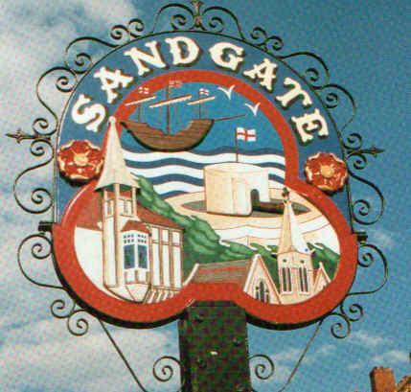

SANDGATE PARISH COUNCIL

Minutes of an Environment Committee Meeting held on
Tuesday 2nd June 2009
~~~~~~~~~~~~~~~~~~~~~~~~~~~~~~~~~~~~~~~~~~~~~~~~~~~~~~~~~~~~~~~~~
Present: Chairman Cllr Z Varian
Councillors: R Dixon, M Fitch and J Holben

Parish Clerk G Baker
~~~~~~~~~~~~~~~~~~~~~~~~~~~~~~~~~~~~~~~~~~~~~~~~~~~~~~~~~~~~~~~~~~~
The meeting opened at 7.30pm
1 Apologies for absence received from Cllrs: G Boot, S Boot, N Bliss and S Prater
2. Declarations of Interest
Councillors and Officers present should disclose personal interests in any item on this agenda. A councillor or Officer with a personal interest must describe and give details of the interest. Unless the personal interest amounts to a prejudicial interest, he/she may participate fully in the meeting.
A prejudicial interest is one, which a member of the public with knowledge of the relevant facts, would reasonably regard as so significant that it is likely to prejudice a councillor’s judgement of the public interest. Anyone with a prejudicial interest must, unless an exception applies of a dispensation granted withdraw from the meeting room.
There were no declarations of interest. None
3. Minutes of last meeting - That the minutes of 5th May 2009, having been circulated were confirmed as a correct record and signed by the Chairman.
Proposed by Cllr M Fitch and seconded by Cllr J Holben and agreed unanimously.

4. Shaun Taylor, Anti-Social Behaviour Manager, Shepway Community Safety Partnership explained that “Environmental Enforcement” is being re-organised and that soon we shall be able to download data regarding the work of Community Officers against dog fouling in Sandgate. Monitoring work continues and our request for more professional looking signage was noted. Shaun also spoke to youth behaviour and detailed the steps undertaken to stop the sale of alcohol to underage drinkers. The benefit to the community of neighbourhood watch programmes was also stressed.

5. Parking and transport issues (ZV) The Transport Advisory Group meeting was well attended and representatives from interest groups had agreed to take on specific tasks to facilitate the production of a dossier to present to Kent Highway Services. Cllr Varian reported that she had met with Sean Spencer, Property Services Manager at Saga and that progress was being made on the anti-social parking issue.
6. Beach: Signage (ZV) - deferred.

7. Conservation Area Appraisal (ZV) This is now on the web site and residents have been asked to submit their comments by 3rd July 2009.

8. Parish Plan and Design Statement (ZV) a steering group meeting has been arranged and there will be an open forum at the Chichester Hall meeting on 23rd June 2009.

9. Plans for Sea Festival (NM) - deferred.

10. Advisory and other committee reports:
Chichester memorial Hall (JH) Cllr Z Varian has now sorted out the finances and the AGM was planned for the end of June.
Youth and Recreation (JH) Cllr J Holben confirmed future activities were in progress. The Sandgate Children’s Craft Club was going well and future dates had been arranged.
Wild Life and Open Spaces (JH) Cllr J Holben confirmed that walks are being arranged.
Sandgate Society (ZV) Cllr Varian continued to liaise regularly via Marjorie Findlay-Stone
11. Date of the next Environment Meeting: 7th July 2009

The meeting closed at 8.40pm

