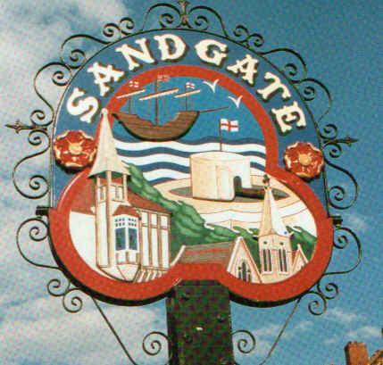

SANDGATE PARISH COUNCIL

Minutes of an Environment Committee Meeting held on
Tuesday 5th May 2009
~~~~~~~~~~~~~~~~~~~~~~~~~~~~~~~~~~~~~~~~~~~~~~~~~~~~~~~~~~~~~~~~~
Present: Chairman Cllr Z Varian
Councillors: R Dixon, M Fitch and S Prater

Parish Clerk G Baker
~~~~~~~~~~~~~~~~~~~~~~~~~~~~~~~~~~~~~~~~~~~~~~~~~~~~~~~~~~~~~~~~~~~

The meeting opened at 7.00pm
1 Apologies for absence received from Cllrs: J Holben, G Boot, S Boot, N Bliss and S Whiffin
2. Declarations of Interest
Councillors and Officers present should disclose personal interests in any item on this agenda. A councillor or Officer with a personal interest must describe and give details of the interest. Unless the personal interest amounts to a prejudicial interest, he/she may participate fully in the meeting.
A prejudicial interest is one, which a member of the public with knowledge of the relevant facts, would reasonably regard as so significant that it is likely to prejudice a councillor’s judgement of the public interest. Anyone with a prejudicial interest must, unless an exception applies of a dispensation granted withdraw from the meeting room.
There were no declarations of interest. None
3. Minutes of last meeting - That the minutes of 31st March 2009, having been circulated were confirmed as a correct record and signed by the Chairman.
Proposed by Cllr R Dixon and seconded by Cllr M Fitch and agreed unanimously.

4 Parking and transport issues (ZV) Cllr. Z Varian updated on various emails which had been received.
A259 Coolinge Road/Radnor Cliff Crescent Junction
Cllr Z Varian has asked K. Ferrin and D Barton (Kent Highways) and M Howard MP to visit the site. Letters of support had been received from Sandgate Primary and Folkestone School for Girls.
Cllr Z Varian suggested setting up a Transport Advisory Group which would report to the Environment Committee and to the Parish Plan and Design Statement Steering Group. Various bodies had been asked for representatives including the Sandgate Society, Radnor Cliff and Riviera residents Association, Sandgate Primary School, Folkestone School for Girls, D Kesby and Cllr S Prater.
Yellow lines
Shepway District Council will review all the yellow lines in Sandgate under one consolidation order to include the changes in Military Road and the removal of yellow lines in the High Street. In addition, parking bays and time restrictions in Sandgate will be amended to give coherence. Our request for less obtrusive narrow primrose colour lines in conservation areas will be considered. There are also plans for a residents’ survey and consultation for a possible parking scheme in the roads around the Saga site.

Cllr Z Varian has been in touch with T Bailey, in charge of security and parking at Saga, regarding anti-social parking.

Drains in Radnor Cliff and Castle Road - are due to be cleared.

5. Beach: Dog Fouling and Signage (ZV) Cllr Z Varian will chase the beach cleaning team to make sure the beach is cleaned regularly.
Signage: only Cllr G Boot had submitted a sample sign and after discussion it was decided that the number of signs, approval and finance will be discussed at the next main council meeting.

6. New Nuclear Build at Dungeness (ZV) The Clerk will scan and email the document to all.

7. Conservation Area Appraisal (ZV) The revised document has still not been posted; Cllr Z Varian will continue to monitor this.

8. Parish Plan and Design Statement (ZV) The next committee meeting will be on 26th May 2009 and the next public meeting will be on 23rd June 2009.

9. Plans for Sea Festival (NM) Cllr N Bliss will report to the next meeting.

10. Advisory and other committee reports:
Chichester Hall (JH) Deferred until the main meeting
Youth and Recreation (JH) Deferred until the main meeting
Wild Life and Open Spaces (JH) Deferred until the main meeting
Sandgate Society (ZV) Cllr Z Varian will write a short report for the next Sandgate Society magazine.

Cllr. R Dixon reported on anti-social behaviour in the Saga grounds on the previous Saturday night. Youths were dinking and caused some damage. Cllr Dixon reported this to the police and she will also write to Saga.

11. Date of the next Environment Meeting: - Yearly schedule to be arrange at the Annual May meeting.

The meeting closed at 8 05 pm

