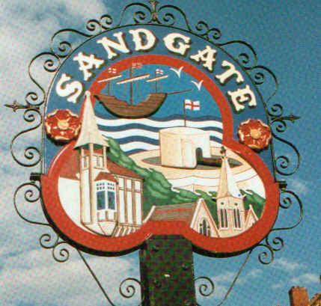

SANDGATE PARISH COUNCIL

Minutes of an Environment Committee Meeting held on
Tuesday 1st September 2009
~~~~~~~~~~~~~~~~~~~~~~~~~~~~~~~~~~~~~~~~~~~~~~~~~~~~~~~~~~~~~~~~~
Present: Chairman Cllr Z Varian
Councillors: R Dixon and A Rimmer

Parish Clerk G Baker
~~~~~~~~~~~~~~~~~~~~~~~~~~~~~~~~~~~~~~~~~~~~~~~~~~~~~~~~~~~~~~~~~~~
The meeting opened at 7.20pm
1 Apologies for absence received from Cllrs: N Bliss, G Boot, S Boot, J Holben and S Prater
2. Declarations of Interest - There were no declarations of interest.
Councillors and Officers present should disclose personal interests in any item on this agenda. A councillor or Officer with a personal interest must describe and give details of the interest. Unless the personal interest amounts to a prejudicial interest, he/she may participate fully in the meeting.
A prejudicial interest is one, which a member of the public with knowledge of the relevant facts, would reasonably regard as so significant that it is likely to prejudice a councillor’s judgement of the public interest. Anyone with a prejudicial interest must, unless an exception applies of a dispensation granted withdraw from the meeting room.
3. Minutes of last meeting - That the minutes of 7th July 2009, having been circulated were amended to include apology from Cllr Dixon and then signed by the Chairman.
Proposed by Cllr Z Varian and seconded by Cllr A Rimmer and agreed unanimously.

4. Report from Transport Advisory Group (ZV, SP, AR) Cllr Z Varian read the minutes of the last TTAG meeting. (Hard copy on Environment File) Cllrs Tolputt and Prater have submitted an application for a flashing “Slow Down” sign and rumble strips on Sandgate Hill. The date of the meeting with KHS in October has yet to be confirmed. Work on the preparation of our case continues and the next meeting is on Thursday 10th September at 6.00pm in the Library. Stagecoach have been asked to attend to discuss buses turning on Sandgate Hill. Cllr Varian explained the case for obtaining expert assistance in the submission of our request for road safety improvements. Community Speed watch will restart when we have a time allocation from Folkestone Town Council.

5. Other Parking and Transport issues (ZV)
Cllr Z Varian read a report following her meeting with Alan Lague, Highways Officer, SDC. (Hard copy on Environment File) A review of yellow lining and parking bays will take place in December, together with a one way system in Castle Road ( Cllr R Dixon asked for Gough Road scheme to be reconsidered) and length restricted bays on the Esplanade to deter lorries from parking overnight.. AL will also consider the best site for a pedestrian crossing on the Esplanade. Adverse comments from residents and the Sandgate Society on the introduction of parking charges in castle Road car park were discussed.

6. Beach: Bathing Water Quality; Signage; (ZV) Cllr Z Varian has a meeting with the Environment Agency on 17th September to discuss their reports on the bathing water failures in May 2009. Bathing Water Quality Reports are now being sent to the Clerk who will distribute them to all councillors and display them in the Parish notice boards. Cllr J Holben has agreed to post them on the Parish website. A copy is also posted in the notice board adjoining the beach on Granville Parade and this board will be repaired shortly. The Clerk has prepared a file for inspection in the Library containing Department of Environment reports and correspondence. Residents’ comments regarding vandalism to the litter bins on the beach and the poor state of Palm House Antiques Shop were discussed and will be brought to the Parish meeting. The invoice for the signs has been received and Cllr Z Varian will follow up installation of same.

- Parish Plan and Design Statement (ZV) The meetings are as follows:
Wednesday 23rd September 11.30am to 2.00pm Gurkha Palace, Golden Valley the draft questions Thursday 24th September 2.00pm to 8pm Chichester Memorial Hall, Sandgate High Street
Saturday 3rd October 10.00am to 1.00pm Sandgate Library, Sandgate
These meetings present an opportunity for our community to review questions before they go to press.
Councillors are being emailed questions as they are prepared for information on residents concerns.

8. Report from Sea Festival (NB) - deferred until Cllr N Bliss returns.

9. Advisory and other committee reports:
Chichester Memorial Hall (RD) Four new trustees had been elected. Costs were awaited for roof repairs but things are moving forward. More letting were being sought and a Farmers’ Market was being looked into.
Youth and Recreation (JH) Report deferred
Wild Life and Open Spaces (JH) Report deferred
Sandgate Society (ZV) Issues raised :
1) Castle Road Car Park. Discussed above
2) State of pavements and street cleaning – the Clerk will pursue
3) Duties of the PCSO – to be discussed at the Parish meeting
4) Car Park next to the Norfolk Hotel - could this be used for public parking? This question had been raised previously in public questions and a written comment will be sought from the Chairman.

10. Date of the next Environment Meeting: TBA

The meeting closed at 8.20pm

Signed by Chairman Environment Committee……………………………………………Date………………………

