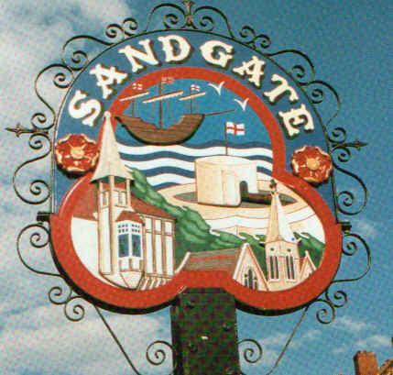

SANDGATE PARISH COUNCIL

Minutes of an Environment Committee Meeting held on
Tuesday 31st March 2009
~~~~~~~~~~~~~~~~~~~~~~~~~~~~~~~~~~~~~~~~~~~~~~~~~~~~~~~~~~~~~~~~~
Present: Chairman Cllr Z Varian
Councillors: R Dixon, M Fitch, S Whiffin, S Boot, G Boot and N Bliss

Parish Clerk G Baker
~~~~~~~~~~~~~~~~~~~~~~~~~~~~~~~~~~~~~~~~~~~~~~~~~~~~~~~~~~~~~~~~~~~

The meeting opened at 7.15pm
1 Apologies for absence received from Cllrs: J Holben and S Prater
2. Declarations of Interest
Councillors and Officers present should disclose personal interests in any item on this agenda. A councillor or Officer with a personal interest must describe and give details of the interest. Unless the personal interest amounts to a prejudicial interest, he/she may participate fully in the meeting.
A prejudicial interest is one, which a member of the public with knowledge of the relevant facts, would reasonably regard as so significant that it is likely to prejudice a councillor’s judgement of the public interest. Anyone with a prejudicial interest must, unless an exception applies of a dispensation granted withdraw from the meeting room.
There were no declarations of interest. None
3. Minutes of last meeting - That the minutes of 3rd March 2009, having been circulated were confirmed as a correct record and signed by the Chairman.
Proposed by Cllr N Bliss and seconded by Cllr R Dixon and agreed unanimously.

- Parking and transport issues (ZV) Cllr. Z Varian has discussed the issue of anti-social Saga parking. with the planning department of SDC and has opened discussions with Saga. Following the parking review, 10 more places are to be created and the cost of doing this has been budgeted for by SDC. Cllr Varian pointed out the dichotomy between the need for additional parking to ensure the economic survival of Sandgate and government environment strategy. Parking provision is being limited in order to encourage people to use public transport but this strategy will only work when public transport is adequate. Stagecoach will be approached again regarding bus routes, particularly through the Golden Valley to the new hub at Folkestone West.
In order to gain momentum for the proposals before KCC highways department, a community speed watch scheme will be investigated. Cllr G Boot will report on a community speed watch share with Elham Council.
Regarding A259 junction at Coolinge Lane and Radnor Cliff Crescent, letters of support for the proposal for a sign and red surfacing have been received from Folkestone School for Girls and Sandgate Primary School have been received - Cllr Varian will continue pursuing this issue.
The steering committee for the Parish Plan and Design Statement have asked that the work necessary for this aspect be continued by the Environment Committee. To this end Cllr Varian will set up a sub-committee of the Environment Committee on parking and transport issues.
Funds for road lining will be discussed at the next Parish Meeting.
Cllr G Boot informed the council he was discussing Sandgate’s car parks with SDC.
Wilberforce Road - Sandgate Parish Council will pay SDC and this would still be free to the public. Castle Road - was still under negotiation. The 3 options regarding this are:
1) For Sandgate Parish Council to pay an increased fee (which would be considerably higher than previous years.
2) For Sandgate Parish council to pay part and for the public to pay a reduced hourly charge.
3) Agree for SDC to charge but for Martello Tower residents to have parking permits.

5. Beach: Dog Fouling and Signage (ZV) Cllr Varian informed the committee that the Community Officers were policing the dog fouling on the beach regularly. Cllr Varian was awaiting information from SDC on the efficacy of the new fines and signage along the beach.
Cllr Z Varian informed the council that litter picks on the beach would be done 6 days a week from 1st May until 30 September 2009.
The graffiti had now been removed.
Signage for camping and bonfires on the beach - Cllr Z Varian asked the members of the council to email her will ideas for these signs.

- Litter Bin on Jacob’s Ladder (ZV) Cllr Z Varian has received complaints of litter on the footpath know as Jacobs’s Ladder (pathway from Sandgate Road to St Stephens Way); the clerk will email SDC requesting that this be put on the street cleaners route.

7. Conservation Area Appraisal (ZV) The revisions to the Conservation Area Appraisal are not yet on the SDC website and Cllr Varian has asked to be informed when this information is posted.

8. Parish Plan and Design Statement (ZV) The Parish Plan and Design Statement Steering Committee has requested that a member of the council (not necessarily the same one) should be included on each sub group.

9. Plans for Sea Festival (NB) Cllr N Bliss informed the council the date had been set for 30th August.
RNLI and Sea cadets are to be involved. As well as the usual stalls, there would also be food stalls involving Sandgate’s restaurants, cafes, pubs etc.
A grant of £1,000 from the Council will be discussed at the Parish Meeting.

10. Advisory and other committee reports:
Chichester Hall (RD) - a meeting was planned for 1st April 2009 and a report given at the Parish Meeting.
Youth and Recreation (JH)) Update email from Cllr J Holben to be read at the Main Parish Meeting.
Wild Life and Open Spaces (JH) Update email from Cllr J Holben to be read at the Main Parish Meeting
Sandgate Society (ZV) Efforts are being made to commemorate HG Wells and others with Blue Plaques.
Public Amenities (GB) Derelict Buildings: Palm House Antiques - progress was being made and scaffolding has now been erected. Fleur De Lys - is now being tidied up.
.
11. Date of the next Environment Meeting: 5th May 2009

The meeting closed at 8 30 pm

