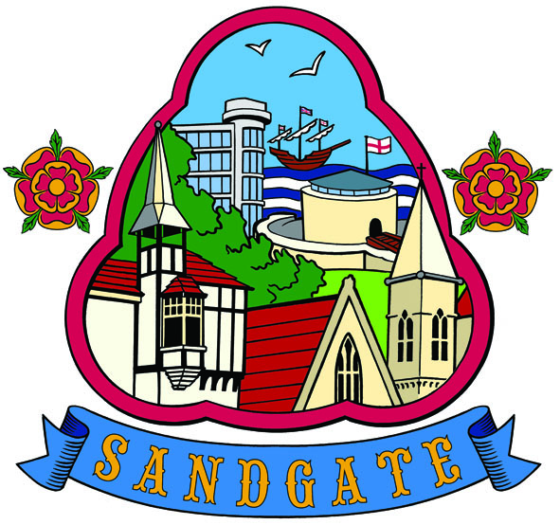
SANDGATE PARISH COUNCIL

Minutes of an Environment Committee Meeting held on
Tuesday 4th May 2010 at 7.00pm
~~~~~~~~~~~~~~~~~~~~~~~~~~~~~~~~~~~~~~~~~~~~~~~~~~~~~~~~~~~~~~~~~
Present: Chairman Cllr Z Varian
Councillors: A Rimmer, S Prater, N Bliss

Parish Clerk Absent: Cllr Varian took the minutes
~~~~~~~~~~~~~~~~~~~~~~~~~~~~~~~~~~~~~~~~~~~~~~~~~~~~~~~~~~~~~~~~~~~
The meeting opened at 7.00pm
- Apologies for absence received from Cllrs: G Boot, S Boot, J Holben and R Dixon

2. Declarations of Interest - There were no declarations of interest.
Councillors and Officers present should disclose personal interests in any item on this agenda. A councillor or Officer with a personal interest must describe and give details of the interest. Unless the personal interest amounts to a prejudicial interest, he/she may participate fully in the meeting.
A prejudicial interest is one, which a member of the public with knowledge of the relevant facts, would reasonably regard as so significant that it is likely to prejudice a councillor’s judgement of the public interest. Anyone with a prejudicial interest must, unless an exception applies of a dispensation granted withdraw from the meeting room.

3. Minutes of last meeting - That the minutes of 6th April 2010 having been circulated were amended to include apologies from Cllr Bliss. Proposed by Cllr A Rimmer and seconded by Cllr. Z Varian.

4. Parking and Transport issues: Cllr Varian reported on the meeting with KHS on 21st April. A thorough review of the issues raised in October was followed by an inspection of Sandgate Hill at close of school day. Our good working relationship with KHS continues but there are few funds available to implement our much needed safety measures. David Barton, KHS urged us to get our County Members, Cllr Tim Prater and Cllr Roland Tolputt to lobby Nick Chard, Cabinet Member for Environment, Highways and Waste on our behalf. (Minutes of this meeting attached)
Junction protection Military Road and environs. Cllr Bliss advised that the section of work at Bybrook Field had not been completed and Cllr Varian said she would follow this up.
Community Speed Watch - Cllr A Rimmer confirmed that she had emailed the 17 members on the rota and that an initial programme would be developed for the rest of the year. Cllrs remarked that they had not seen CPSO Mark Wilson lately and that this should be referred to Parish meeting.

5. Beach: Meeting with Stephen Courts, SDC: Cllr Varian reported that she had spent two hours walking through Sandgate with Stephen Courts, who is responsible for dog fouling issues. All cleaning operatives are now permitted to issue fines but despite best efforts of dog warden and others, no fines have yet been issued. The extension of the “Dogs on Leads” prohibition in the Coastal Park was raised as was the definition of the existing beach ban area. A programme will be undertaken by Parish to issue leaflets with poo sacks to dog owners and new labels will be added to the litter bins to say that they accept dog excrement.
Report from meeting with Chris Kirkham and Blue Flag Application: Cllr Prater advised that the deadline for this year was fast approaching but that after the election she and Cllr Varian will try to get this work underway.
Solarium: The Sandgate Society have sent details of an advisor and Chris Kirkham suggested that we ask Folkestone Artists’ Cooperative to put on Punch and Judy or Fire eating Shows on Bank Holidays. Cllr Varian suggested that Summer 2010 would be a trial run to allow us to see what the possibilities might be.
Public Covenience: Since the last meeting Cllr Varian had been exploring the various ways that the improvements around the Public Convenience might be funded and was pleased to report that there was a lot of support for the project, which may also form part of the Blue Flag and Interreg projects.

6 Parish Plan and Design Statement - Marjorie Findley Stone reported that the public meeting on the 28th April had been well attended and that the steering committee was meeting on Wednesday 5th May to discuss the way forward.

7 Advisory and other committee reports: Chichester Memorial Hall (ZV) The farmers market is going well and the first Art Market is on 8th May 2010. Local traders had reported an upturn in trade since the inception of the market. Cllr Varian also reported that there are two further arts shops opening shortly in addition to The Hub cycle shop and coffee bar and that Sandgate could become known as an “Arts Destination”.
Sandgate Society: Cllr Varian reported that the society were involved in the Solarium project already discussed and it was hoped that they would get involved with the Blue Flag project.

Date of the next Environment Meeting 6th July 2010
The meeting closed at 8.30 pm

Signed by the Chairman Environment Committee…………………………………Date………………

