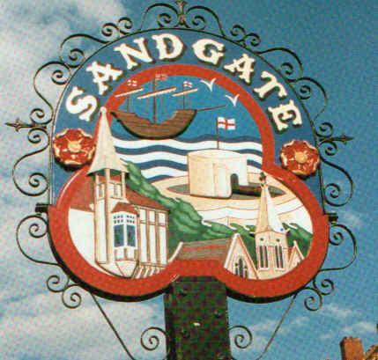

SANDGATE PARISH COUNCIL

Minutes of an Environment Committee Meeting held on
Tuesday 3rd February 2009
~~~~~~~~~~~~~~~~~~~~~~~~~~~~~~~~~~~~~~~~~~~~~~~~~~~~~~~~~~~~~~~~~
Present: Chairman Cllr Z Varian
Councillors: N Bliss, M Fitch, R Dixon J Holben and S Prater

Acting Parish Clerk Z Varian
~~~~~~~~~~~~~~~~~~~~~~~~~~~~~~~~~~~~~~~~~~~~~~~~~~~~~~~~~~~~~~~~~~~

The meeting opened at 7.05pm
- There were no apologies for absence
2. Declarations of Interest
Councillors and Officers present should disclose personal interests in any item on this agenda. A councillor or Officer with a personal interest must describe and give details of the interest. Unless the personal interest amounts to a prejudicial interest, he/she may participate fully in the meeting.
A prejudicial interest is one, which a member of the public with knowledge of the relevant facts, would reasonably regard as so significant that it is likely to prejudice a councillor’s judgement of the public interest. Anyone with a prejudicial interest must, unless an exception applies of a dispensation granted withdraw from the meeting room.
There were no declarations of interest.
3. Minutes of last meeting - That the minutes of 6th January2009, having been circulated were confirmed as a correct record and signed by the Chairman.
Proposed by Cllr S Prater and seconded by Cllr R Dixon.

4. Parking and transport issues (ZV) Cllr Z Varian informed the councillors that she had received a minute written by Anne Norton following the public consultation with KHS on 7th January 2009. Cllr Varian assured the meeting that every effort would be made to expedite parking and transport issues in Sandgate. The report was read and commented upon:
A259 junction at Coolinge Lane and Radnor Cliff Crescent
Cllr Varian has written to Keith Ferrin, KHS, to ask for his criteria for the guidelines for transport scheme assessment. Local Transport Plan assessment and therefore funding only takes account of sites where crashes have resulted in personal injury and have been reported to Kent Police.
Funding will be sought for a “slow down” sign AND red surfacing.
Revised Travel Plans for Sandgate Primary School and Folkestone School for Girls will emphasise the hazards at the junction and will provide evidence for the assessment process for a crossing.
Cllr Varian will liaise with Folkestone Town Council, who have Speed Watch equipment, and Kent Police regarding a speed check.
Pedestrian Crossing on the Esplanade at Brewer’s Hill
The assessment for this site will be reconsidered and put forward for 2010/11 LTP funding
Traffic Speeds
Sandgate will be included in the countywide speed limit review and a traffic count will be ordered to assess the volume and speed of traffic. This work will be completed by 2011 when its recommendations will be implemented.
Road Repairs
The Highway Inspector and Operations Engineer have been asked to visit Radnor Cliff to assess subsidence and general condition.

5. Beach: Introduction of Bye-Laws (ZV) Cllr Z Varian has an appointment with SDC on 9th February to investigate signage regarding camping and bonfires. Community Officers are currently patrolling the beach and have put up new signs warning of fines for dog fouling. Councillors asked whether leaflets could be produced to hand out to dog owners.

6. Parish Plan and Design Statement (JH) - Cllr J Holben advised that the first meeting would be held on 19th February 2009 at 7.00pm and she had invited all those people who had expressed an interest in joining the group.

7. 200th Anniversary of Sir John Moore’s Death (JH, GB, ZV) Cllr Z Varian thanked Cllr J Holben for her hard work during a very successful celebration and the Parish Clerk’s contribution to its success was also noted.

8. Advisory and other committee reports:
Public Amenities including land acquisition (MF, GB) To be considered at parish meeting.
Chichester Hall (JH) Cllr J Holben reported that the CMH was now on an even keel and that nominations for new trustees from residents would be sought at the AGM in May. Frank and Sheila Rodrigues, the new caretakers, were thanked for their hard work and involvement with the project. Cllr Holben asked for volunteers for small repair jobs at the Hall.
Youth and Recreation (JH) Cllr J Holben reported that this valuable work is continuing with Clive Harris, the Community Youth Worker. Young people from the group have been put forward for a film project under the auspices of the Find Your Talent Scheme. The proposals to develop the Military Road Recreation ground are in hand but this work is contingent upon the Parish Council’s plans to purchase the site from SDC.
Wild Life and Open Spaces (JH) Cllr J Holben said that the group’s work in reporting overgrown or dangerous paths was continuing and that 50 oak trees supplied by The White Cliffs Countryside Project were to be planted in the Saga woodland. Organised litter picks had been abandoned for the moment but Cllr Holben continued to collect litter. The badger set in Golden Valley continues to thrive.
Sandgate Society (ZV) Cllr Z Varian asked if any councillor would like to attend the
Sandgate Society meetings held on the last Wednesday of each month. Cllr Varian has written to the Sandgate Society to thank them for the splendid display in the Library and accompanying literature.

9. Date of the next Environment Meeting: 3rd March 2009

The meeting closed at 8.30pm

Chairman of the Environmental Committee...…………………..………… Date ………………

