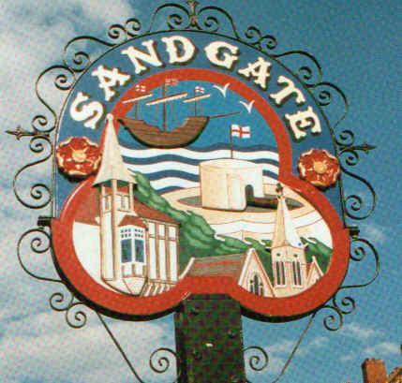

PARISH COUNCIL MEETING

Minutes of the meeting held on Tuesday 11th November 2008
At Sandgate Parish Council Library & Officers, James Morris Court, Sandgate
~~~~~~~~~~~~~~~~~~~~~~~~~~~~~~~~~~~~~~~~~~~~~~~~~~~~~~~~~~~~~~~~~~~~~~~~~~~~~~~~~~~~~~~~~~~~~~
Present: Chairman Cllr G Boot
Cllrs. S Boot, M Fitch, R Dixon S Prater and N Bliss
Parish Clerk G Baker
~~~~~~~~~~~~~~~~~~~~~~~~~~~~~~~~~~~~~~~~~~~~~~~~~~~~~~~~~~~~~~~~~~~~~~
Public Questions (20 mins). (Unfortunately the PCSO on duty failed to attend to give a short presentation prior to the public questions.)

Twenty minutes had been set-aside for the public to ask questions of the Council. Each member of the public wishing to put a question informed the Parish Clerk at the time of their arrival at the meeting and questions were put accordingly. Speakers were allowed a maximum of two minutes to put his or her question. The Parish Council endeavoured to answer any question put to them within the time limit of two minutes, but if necessary may have to contact the questioner at a later date with an answer, or consider placing the matter on the agenda for the next meeting for a more lengthy discussion.

The Meeting opened at 7 10pm
1. Apologies for absence - Cllrs: .H Marshall, J Holben, J Hartman-Jemmett, Z Varian and
S Whiffin
2. Declarations of Interest
Councillors and officers present should disclose personal interests in any item on this agenda. A councillor or officer with a personal interest must describe and give details of the interest. Unless the personal interest amounts to a prejudicial interest, he/she may participate fully in the meeting.
A prejudicial interest is one, which a member of the public with knowledge of the relevant facts, would reasonably regard as so significant that it is likely to prejudice a councillor’s judgement of the public interest. Anyone with a prejudicial interest must, unless an exception applies of a dispensation granted withdraw from the meeting room.

3. Minutes of last meeting - That the minutes of 14th October 2008, having been circulated were confirmed as a correct record and signed by the Chairman. Proposed Cllr M Fitch, seconded by Cllr N Bliss and agreed unanimously.
4 Chairman's opening remarks - The Remembrance Day ceremony at the church and memorial were well attended, as was the reception in Gate 28 afterwards. The Community Plan Design Statement public meeting went well and was a good example of community engagement.

5 Chairman's correspondence - The Chairman’s correspondence was read and addressed.

6 Chichester Hall update - a new bank account has been set up and a meeting of the new trustees was immanent.
7 Library update - The Council is awaiting news from KCC Libraries with regard to extended opening.

8 Folkestone Parks & Pleasure Ground Charity transfer- correspondence has been received and plans are progressing slowly.

9 Community land update -meetings have taken place and plans are progressing.

10 Christmas light update - Cllr N Bliss reported the lights had been ordered and Golden Valley would have a Christmas tree this year. The lights are due to be switched on Saturday 30th November at 6 pm outside the Fish and Chip shop in Sandgate and that refreshments etc. would be available.
11 Sandgate Parish Council aims and objectives - a list of Sandgate Parish Council’s
‘Aims & Objectives’ was circulated to the council. A proposal to accept these was proposed by Cllr N Bliss, seconded by Cllr S Boot and agreed unanimously.

12 Parish Plan + Design Statement - Cllr J Holben to update at the next main parish meeting.

13 Sir John Moore commemorative event - A community survey has been completed and there are a number of ideas. These will be examined in more detail to form the basis of an event in the New Year.

14 Daffodil planting update - the daffodil bulbs have been ordered and planting will take place soon.
15 Environment Committee report - deferred until next meeting.

16 Finance Committee report -a meeting regarding the precept is due to take place.

17 Planning Committee report - Planning applications for discussion received until 4 11 08

Application No | Location | Detail | Decision
Y08/0984/SH | 26 Battery Point Hythe Kent CT21 5RR | ERECTION OF A REAR CONSERVATORY, T0GETHER WITH FORMATION OF HARD SURFACE AREA WITHIN FRONT CURTILAGE | Received 17 10 08  Comments by 3 11 08  Not in the Sandgate area.
Y08/1025/SH | Kent Auto Panels Ltd Ross Way Folkestone | DISPLAY OF ONE NON ILLUMINATED BANNER SIGN TO THE SOUTHERN BOUNDARY, ONE NON ILLUMINATED EXTERIOR WALL SIGN TO THE FRONT ELEVATION AND ONE REPLACEMENT FLAG SIGN | Received 17 10 08  Comments by 5 6 08  No discussion needed RD
Cllr R Dixon Chairman of the Planning Committee reported that no plans had been received that need discussion
18 Personnel Committee report the personnel meeting scheduled for 11th November was re- scheduled for 8thJanuary.

19 Information items -There were no items of note.
20 Date of next Council meeting 9th December 2008 followed by refreshments.
21 Exclusion of press and public - no discussions needed.

Chairman of Council ..…………………………… Date ………………

The meeting closed at 8 pm.

