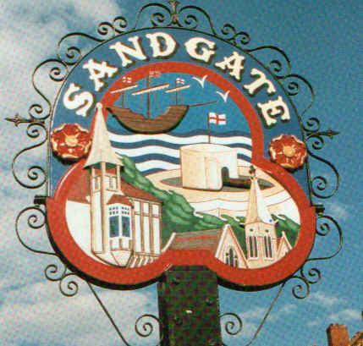

SANDGATE PARISH COUNCIL

Minutes of an Environment Committee Meeting held on
Tuesday 6th January 2009
~~~~~~~~~~~~~~~~~~~~~~~~~~~~~~~~~~~~~~~~~~~~~~~~~~~~~~~~~~~~~~~~~
Present: Chairman Cllr Z Varian
Councillors: M Fitch, R Dixon and S Prater

Parish Clerk G Baker
~~~~~~~~~~~~~~~~~~~~~~~~~~~~~~~~~~~~~~~~~~~~~~~~~~~~~~~~~~~~~~~~~~~

The meeting opened at 7pm
1 Apologies for absence received from Cllrs: G Boot, S Boot, J Holben and N Bliss
2. Declarations of Interest
Councillors and Officers present should disclose personal interests in any item on this agenda. A councillor or Officer with a personal interest must describe and give details of the interest. Unless the personal interest amounts to a prejudicial interest, he/she may participate fully in the meeting.
A prejudicial interest is one, which a member of the public with knowledge of the relevant facts, would reasonably regard as so significant that it is likely to prejudice a councillor’s judgement of the public interest. Anyone with a prejudicial interest must, unless an exception applies of a dispensation granted withdraw from the meeting room.
There were no declarations of interest.
3. Minutes of last meeting - That the minutes of 2nd December 2008, having been circulated were confirmed as a correct record and signed by the Chairman.
Proposed by Cllr S Prater and seconded by Cllr R Dixon.

4. Parking and transport issues (ZV) Cllr Z Varian informed the councillors that an open meeting had been arranged for 2pm on Wednesday 7th January 2009, with representatives from Shepway District Council, Kent Highway Services, District Councillor Robert Bliss and County Councillor Roland Tolputt having been invited. Following an open discussion with interested parties present, a list of priority topics were decided upon: 1) A259 junction with Radnor Cliffe Crescent and Coolinge Lane. 2). Brewers Hill Crossing. 3) Speed Limit. The aim of the open meeting is to provide KHS with a clear understanding of the needs of the village and that we can learn what is achievable, the cost and time frame in order to expedite parking and transport requirements.

5. Beach: Introduction of Bye-Laws (ZV) Having reviewed bye-laws at the last meeting the consensus was that we should investigate signage at this time and that Cllr Varian will engage with SDC to encourage dog-warden to patrol the gangway.

6. Parish Plan and Design Statement (JH) - Cllr J Holben will update at the main parish meeting

7. 200th Anniversary of Sir John Moore’s Death (JH, GB, ZV) The list of celebratory events was read out, together with details of the exhibition in the Library.

8. Advisory and other committee reports:
Public Amenities including land acquisition (MF, GB) To be considered at parish meeting.
Chichester Hall (JH) Update after next meeting on 13th January 2009
Youth and Recreation (JH) No report
Wild Life and Open Spaces (JH) No report
Sandgate Society (ZV) Cllr Z Varian informed the council the Sandgate Society had written thanking councillors for their work on parking and transport issues. A invitation to councillors to attend the
Sandgate Society meetings on the last Wednesday of each month was extended.

9. Date of the next Environment Meeting: 3rd February 2009

The meeting closed at 8.15pm

Chairman of the Environmental Committee...…………………..………… Date ………………

