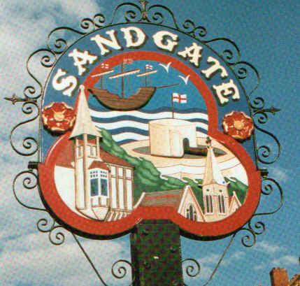

PARISH COUNCIL MEETING

Minutes of the meeting held on Tuesday 11th July 2006
~~~~~~~~~~~~~~~~~~~~~~~~~~~~~~~~~~~~~~~~~~~~~~~~~~~~~~~~
Present:

Chairman Cllr. J Greenwall
Cllrs. S.Whiffin (Vice Chairman) R MacMillan, Mrs M Wells, Mrs R Dixon, Mrs J Bailey<
Mr M Fitch and Mr M Lyons
LocumParish Clerk Mrs G Baker
~~~~~~~~~~~~~~~~~~~~~~~~~~~~~~~~~~~~~~~~~~~~~~~~~~~~~~~~~~

The Chairman Cllr Jonathan Greenwall opened the meeting at 7.00 pm. There were 25 members of the public in attendance.

1. Apologies for absence

Apologies received from Cllr’s Mrs J MacMillan, Cllr. Mr R Bliss and at this point a letter was read out from Cllr. Mr H Noonan tendering his resignation.

2. Declarations of Interest

Cllr Mrs R Dixon declared a personal interest in planning application Y06 0843 SH and therefore left the meeting whilst this was discussed.

3. Minutes of the last meeting

The minutes of the meeting held on 13th June 2006, having been circulated, were confirmed as correct record and signed by the Chairman

The public were informed that these can be found on the notice boards (and website)

The motion that the minutes be confirmed as a correct record and signed was put forward and was-
Proposed Cllr Mr M Lyons
Seconded Cllr Mrs R Dixon
Agreed Unanimously.

4. Public questions
A ten-minute period was set-aside for the public to ask questions of the Council. The Parish Council endeavoured to answer all questions put to them most of these were answered but some needed to be chased up in respect of:

a) The condition of the Kirby Arcade was mentioned and the Chairman will look into this.

b) The quality of the sea water and beach was asked about and it was agreed that we would contact Southern Water for this information.

5. Chairman’s correspondence

The Chairman read out a number of communications that had been received. All had been acknowledge and noted. Please see below for correspondence and
any follow up action.

a) A request for a donation from Rachel Elvey regarding ‘Student Nurse Volunteer Project to India’. – was agreed that it would be inappropriate to use public funds for this project.

b) One way street in Sandgate Parish Council - already replied.

c) Oxenden Road Traffic – This will be looked into.

d) Parking Issues in Sunnyside - we will check where the previous yellow lines had been.

e) Tubs – When Cullum returns he will deal with this.

f) Rubbish bins – Shepway District Council will be chased regarding this.

g) A letter from Folkestone Town Council regarding a meeting at the Woodward Hall on 13th July 2006 at 7pm parks and pleasure grounds (re the coastal path) Cllr R MacMillan agreed to attend.

h) The Chairman also read out a letter from Kent Association of Parish Councils Shepway Area Committee. Re: Shepway District Standards Committee. It was agreed to support them and a letter will be sent.
Proposed by Cllr. M Lyons
Seconded by Cllr. B. MacMillan.
Agreed unanimously

6. Environment Committee reported about:

a) Litter on the beach which the seagulls scattered from contents of the bags left by the bins. Cllr S Whiffin suggested that a skip should be hired from 1st April until 30th September at a cost of £7 to £11 per week – this was
Proposed by Cllr. J Greenwall
Seconded by Cllr. M. Wells
Agreed unanimously.

b) Cllr M Wells also mentioned lots of tents on the beach and that people were camping there. We will ring and find out the rules regarding this.

c) It was mentioned that the Sea Cadets in Castle Road had a lot of junk and it was suggested that we get Shepway District Council to put pressure on to clear this.

7. Finance Committee report – nothing to report.

8. Planning Committee report

Cllr S Whiffin read out the Planning Applications that had been dealt with by the Planning Committee. Please see appendix 1.

In addition Cllr. Whiffin informed the meeting that the planning inspectorate had refused the Encombe appeal and the planning application for the Folkestone School for Girl Penfold House development had been withdrawn.

9. Foster Master Plan Nick Ewbank, Director of the Creative Foundation gave an overview of the Folkestone harbour and seafront master plan proposed by Roger De Hann. This presentation was both interesting and informative and a number of questions were answered fully.

10 Date of next Sandgate Parish Council meeting

Tuesday 12th September 2006 at 7.00 pm

at Sandgate Parish Council Library, James Morris Court, Sandgate High Street.

The Clerk will publicise these dates on the website and in the notice boards.

There being no further business the meeting closed at 9 pm

Member of the Council ..…………………………… Date ………………
(Or Chairman)

