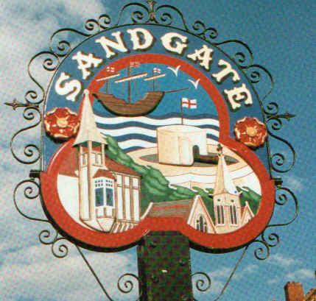

PARISH COUNCIL MEETING

Minutes of the meeting held on Tuesday 12th December 2006

~~~~~~~~~~~~~~~~~~~~~~~~~~~~~~~~~~~~~~~~~~~~~~~~~~~~~~~~
Present: Chairman Cllr Jonathan Greenwall
Cllrs. S Whiffin , R MacMillan, M Wells, M Lyons, J Bailey, M Fitch, R Dixon and J MacMillan.
Locum Parish Clerk G Baker
~~~~~~~~~~~~~~~~~~~~~~~~~~~~~~~~~~~~~~~~~~~~~~~~~~~~~~~~~~

The Chairman Cllr Jonathan Greenwall opened the meeting at 7.00 pm. There were 12 Members of the public in attendance.

1. Apologies for absence H Noonan

2. Declarations of Interest - there were no declarations of interest.

3. Minutes of the last meeting
The minutes of the meeting held on 7th November 2006 having been circulated, were confirmed as correct record and signed by the Chairman.

The motion that the minutes be confirmed as a correct record and signed was put forward, was proposed by Cllr M Lyons, Seconded Cllr M Wells Agreed Unanimously.

4. Public questions
A ten-minute period was set-aside for the public to ask questions of the Council. The Parish Council endeavoured to answer all questions put to them.

a) A member of the public - asked about the possibilities of the Chichester Hall
Cllr J Greenwall and Cllr R MacMillan explained that the council had been in touch with the trustees but was told not to interfere. The member of the public asked if anything could be done – the council agreed to make contact again with the trustees and the member of the public will ask for Shepway District Council’s help.

6. Chairman’s correspondence - The Chairman read out a number of communications that had been received. All had been acknowledge and noted.

a) Folkestone Parks and Pleasure Grounds – letter from L Avery – the Chairman read out a letter regarding Folkestone taking over the Sandgate part of the Parks and Pleasure Grounds on the seafront (April 2008 transfer date).

b) Car Park Charges –we have been advised there will be a 5% (approx) increase for next year it was proposed we agree it by Cllr J Greenwall, seconded by Cllr J MacMillan and agreed unanimously.

c) Sandgate Soc -invitation to their annual January 2007 meeting.

d) Letter from a member of the public – regarding moving the bus stop a little more west along the esplanade ending where it now begins this would provide an extra parking place. It was decided to send a copy of the letter to S Gasche at Shepway District Council.

e) Invitation from the Council at Sangatte - Cllr M Lyons and 2 representatives from the Twinning Association to meet for lunch and discuss a sports event that may be happening June 07.

7 Ghurkha Day update - Cllr J Greenwall gave an update – it will now take place sometime in January 2007.

8. Environment Committee report a member of the environmental committee reported the meeting of 5th December 2006.

9. Finance Committee report - Cllr R MacMillan reported on the financial position. Mentioning Folkestone Parks and Pleasure (See 6a) and car parking charges (see 6b).

The Ghurkha’s Freedom Day it is customary that they be given a scroll and also a key so it was proposed that we purchase these - proposed by Cllr R MacMillan, seconded by Cllr M Lyons and agreed unanimously.

10. Planning Committee report Cllr S Whiffin read out the Planning Applications that had been dealt with by the Planning Committee on 5th December 2006.

Planning Applications Received from 7th November 2006 - 5th Dec 2006
Application Number | Location | Detail | Decision
Y06/1425/SH | Land opposite 14-16 Lower Corniche Hythe Kent CT21 5TP | Non-compliance with condition 10 of planning permission Y02/0131/SH (requiring landscape works) for retention of existing hard surfaced area as parking Bays. | Letter to be sent  Re Objection

Cllr Whiffin updated the committee on Planning Application SH/06/660 Ross Depot, Military Road Folkestone - Variation of Condition regarding Bank Holiday Working - the council have been informed that this has been withdrawn and no further action will be taken.

11. Date of next Sandgate Parish Council meeting
Tuesday 9th January 2007 at 7 00 pm.
Sandgate Parish Council Offices, James Morris Court, Sandgate High Street, Sandgate, Kent
.

The Clerk will publicise these dates on the website and in the notice boards.

There being no further business the meeting closed at 7. 55 pm

Chairman of the Council.…………………………… Date ………………

