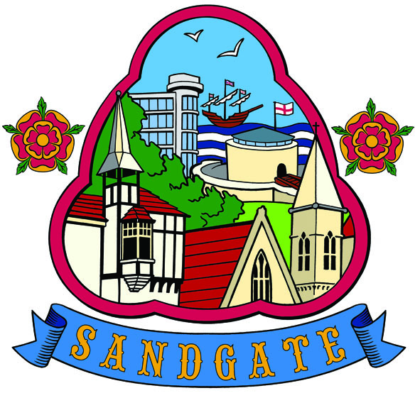

SANDGATE PARISH COUNCIL MEETING
Date: 14th June 2011 Time: 7.00pm
Venue: Sandgate Council and Library, Sandgate High Street.
To ALL MEMBERS OF SANDGATE PARISH COUNCIL
YOU ARE HEREBY SUMMONED to attend a Sandgate Council meeting on the date and at the time and place shown above. The meeting will be open to the press and public. Sandgate Parish Clerk
~~~~~~~~~~~~~~~~~~~~~~~~~~~~~~~~~~~~~~~~~~~~~~~~~~~~~~~~~~~~~~~~~~~~~~~~~~~~~~~~~~~~~~~
Public Questions (20 mins) (including a short update by Sandgate’s PCSO before the start of the meeting.)

20 minutes have been set-aside for the public to ask questions of the Council. Each member of the public wishing to put a question will inform the Parish Clerk at the time of their arrival at the meeting and questions will be put accordingly. Speakers will be allowed a maximum of two minutes to put his or her question. The Parish Council will endeavour to answer any question put to them within the time limit of two minutes, but may have to contact the questioner at a later date with an answer, or consider placing the matter on the agenda for the next meeting for a more lengthy discussion.

Presentation by Chris Kirkham - Discover Folkestone
AGENDA
1 Apologies for absence
2 Declarations of Interest
Councillors present should disclose personal interests in any item on this agenda. A councillor with a personal interest must describe and give details of the interest. Unless the personal interest amounts to a prejudicial interest, he/she may participate fully in the meeting.
A prejudicial interest is one, which a member of the public with knowledge of the relevant facts, would reasonably regard as so significant that it is likely to prejudice a councillor’s judgement of the public interest. Anyone with a prejudicial interest must, unless an exception applies of a dispensation granted withdraw from the meeting room
- Minutes of APCM
- Chairman’s opening remarks
- Chairman’s correspondence
- Approval of Accounts
- Completion of the Annual Return
- Finance Committee report
- Grant towards Tourism Promotion
- Grant applications received (if any)
- To agree the release of up to £1,200 to fund a design statement and principles for the redevelopment of the area around Granville Parade toilets and the wider area. (TP and MFS
- PC newsletter (JH)
- Rubbish bins (recreation ground and any others? (JH)
- Caretaker/gofer/handyman (JH)
- Environment Committee report
- Advisory Group members (Business, Traffic and Parking & Beach Management) (TP)
- Planning Committee report - Plans discussed since last meeting.
Application No |  | Location | Details | Decision
Y11/0410/SH | Cirilla Radnor Cliff Cres Sandgate |  | Erection of first floor extension to infill existing first floor Front/side balcony area | Received 6 5 11  Comments by 24 5 11 + 2days extension  No Objection x 4
Y11/0234/SH | Clewer Hse Coolinge Lane |  | Outline application for the erection of five dwellings following demolition of Clewer Hse | Received 9 5 11  Comments by 26 5 11  No Objection x 4  Comments: No objection subject to access road of sufficient width with appropriate parking restrictions
Y11/0459/SH | White Lodge Coolinge Lane |  | Demolition of Dwelling House (28 day Notification) | Received 16 5 11  Comments by 1 6 11  No Objection x 4
Y11/0462/SH | 9 The Crescent Sandgate |  | Erection of a four storey block of two flats including accommodation in the roof space and off street parking (resubmission of planning application Y10/1166/SH | Received 31 5 11  Comments by 16 6 11  Objection x 4  On Policy BE4, the committee does not feel the development improves upon the existing character of the crescent as a conservation area. The front of the development appears cluttered compared with neighboring properties.
Y11/0411/SH | 36 Lower Corniche Hythe CT21 5TP |  | Erection of a rear conservatory | Received 23 5 11  Comments by 8 6 11  No Objection x 4

18 Information
19 Date of the next Parish Meeting

