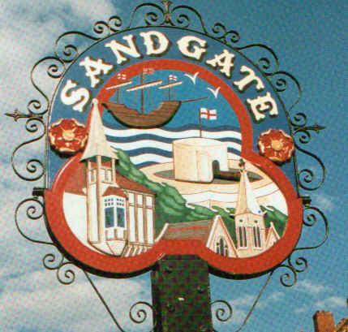

SANDGATE PARISH COUNCIL

ENVIRONMENT COMMITTEE MEETING
To be held at 7.00 pm on Tuesday 7th February 2012

Sandgate Parish Council Library & Offices
James Morris Court
Sandgate High Street, Sandgate
~~~~~~~~~~~~~~~~~~~~~~~~~~~~~~~~~~~~~~~~~~~~~~~~~~~~~~~~~

AGENDA
1. Apologies for absence

2. Declarations of Interest
Councillors present should disclose personal interests in any item on this agenda. A councillor with a personal interest must describe and give details of the interest. Unless the personal interest amounts to a prejudicial interest, he/she may participate fully in the meeting.
A prejudicial interest is one, which a member of the public with knowledge of the relevant facts, would reasonably regard as so significant that it is likely to prejudice a councillor’s judgement of the public interest. Anyone with a prejudicial interest must, unless an exception applies of a dispensation granted withdraw from the meeting room.

3. Minutes of the last meeting - that the minutes of the last meeting held on 6th December having been circulated be confirmed as a correct record and signed

4. Communication

5. Transport and Parking Advisory Group report - NG

6. Beaches Advisory Group report to include a summary report of the Shepway Coastal Recreation Strategy– TH/MFS

7. Business and Tourism Advisory Group report– TP

8. Chichester Memorial Hall update – JH

9. Youth and recreation update – JH

10. Wild life and open spaces update – links to Parish Plan and recreational facilities
i. Outdoor gym trail – suggested location of equipment and estimate of costs for equipment and its installation - JH/MFS
ii. Installation of bird boxes to include costing

11. Report back from Shepway Cycle Forum - MFS

12. Jubilee celebrations in Sandgate – NB/MFS

13. Electronic messaging boards – MFS
Proposal to put before full council at the next meeting, a budget to purchase:
i. Electronic messaging boards
ii. Stretched pictures for empty shops

14. Community Payback Scheme
Proposal to put before full council at the next meeting, a budget to purchase:
i. A storage box for equipment

15. Sandgate Society report - MFS

16. Terms of Reference
To review and agree previously circulated draft Terms of Reference for Environment meetings, for approval at the next main council meeting

17. Information

18. Date of the next meeting 6th March 2012

