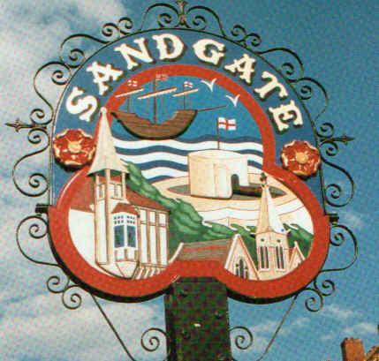

SANDGATE PARISH COUNCIL

ENVIRONMENT COMMITTEE MEETING
To be held at 7.00 pm on Tuesday 6th September 2011

Sandgate Parish Council Library & Offices
James Morris Court
Sandgate High Street. Sandgate.

~~~~~~~~~~~~~~~~~~~~~~~~~~~~~~~~~~~~~~~~~~~~~~~~~~~~~~~~~

AGENDA

- Apologies for absence
Marjorie Findlay-Stone (Cllr JanHolben will be in the Chair)

2. Declarations of Interest
Councillors present should disclose personal interests in any item on this agenda. A councillor with a personal interest must describe and give details of the interest. Unless the personal interest amounts to a prejudicial interest, he/she may participate fully in the meeting.
A prejudicial interest is one, which a member of the public with knowledge of the relevant facts, would reasonably regard as so significant that it is likely to prejudice a councillor’s judgement of the public interest. Anyone with a prejudicial interest must, unless an exception applies of a dispensation granted withdraw from the meeting room.

3 Minutes of last meeting - that the minutes of 5th July 2011 having been circulated, be confirmed as a correct record and signed.

4 Communications – JH

5. Christmas Lights event - NB

6. Report from Transport and Parking advisory group - NG

7. Report from Beaches Advisory Group – TH

8. Report from Business and Tourism Advisory Group – TP

9. Reports on
- Chichester Memorial Hall – JH
- Comments on Sea Festival - NB
- Youth and Recreation – JH
- Wild life and open spaces – links to Parish Plan and recreational facilities – JH
- Sandgate Society - MFS

9 Date of the next meeting Would councillors please consider moving this meeting to Tuesday 27th or Wednesday 28th September as MFS will be away the following week.

