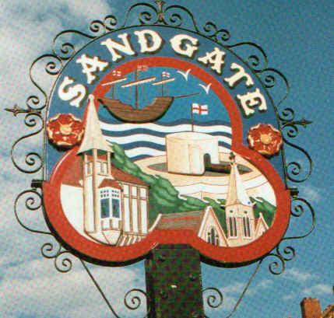

SANDGATE PARISH COUNCIL MEETING
Date: 8th September 2009. Time: 7.00pm
Venue: Sandgate Council and Library, Sandgate High Street.
To ALL MEMBERS OF SANDGATE PARISH COUNCIL
YOU ARE HEREBY SUMMONED to attend a Sandgate Council meeting on the date and at the time and place shown above. The meeting will be open to the press and public. Sandgate Parish Clerk
~~~~~~~~~~~~~~~~~~~~~~~~~~~~~~~~~~~~~~~~~~~~~~~~~~~~~~~~~~~~~~~~~~~~~~~~~~~~~~~~~~~~~~~
Public Questions (20 mins) (including a short presentation by Sandgate’s PCSO before the start of the meeting.)

Twenty minutes have been set-aside for the public to ask questions of the Council. Each member of the public wishing to put a question will inform the Parish Clerk at the time of their arrival at the meeting and questions will be put accordingly. Speakers will be allowed a maximum of two minutes to put his or her question. The Parish Council will endeavour to answer any question put to them within the time limit of two minutes, but may have to contact the questioner at a later date with an answer, or consider placing the matter on the agenda for the next meeting for a more lengthy discussion.

Meeting to start at 7 20pm
AGENDA

- Apologies for absence
- Declarations of Interest
Councillors and officers present should disclose personal interests in any item on this agenda. A councillor or officer with a personal interest must describe and give details of the interest. Unless the personal interest amounts to a prejudicial interest, he/she may participate fully in the meeting.
A prejudicial interest is one, which a member of the public with knowledge of the relevant facts, would reasonably regard as so significant that it is likely to prejudice a councillor’s judgement of the public interest. Anyone with a prejudicial interest must, unless an exception applies of a dispensation granted withdraw from the meeting room.
- Minutes of last meeting
- Chairman's opening remarks
- Chairman's correspondence
- Litter Bins
- Folkestone Parks & Pleasure Ground Charity update
- Newsletter [JH]
- L.D.F Consultation and response.
- Traffic/Parking Costs update
- Footpath Order
- Speedwatch Camera update + purchase request
- Parish Plan + Design Statement update
- Palm House Antiques (ZV)
- Land Acquisition
- PCSO (ZV)
- Costs of £350 re Safety Measures in Connection with meeting with KHS (in Oct)
- Funding for Audio Post (JH)
- Environment Committee report
- Planning Committee report

Y09/0590/SH | 19 Radnor Cliff Folkestone | Construction of a new roof over existing coach house to provide a garden room | Received 1 7 09  Comments by 20 7 09  No Objection  Returned to SDC 15 7 09
Y09/060/SH | Capthorne the Undercliff Sandgate | Erection of a single storey Flat Roof Extension to Second Floor Terrace Together with erection of Railing to Existing Parapet. | Received 7 7 09  Comments by 26 6 09  No Objection  Returned to SDC 15 7 09
Y09/0665/SH | 5 Radnor Cliff Folkestone CT20 2JW | ALSTERATIONS TO CREATE A TWO-STOREY DWELLING WITH ROLLED STEEL BUTTERFLY ROOF | Received 13 7 09  Comments by 30 7 09  Not enough members for a formal meeting to take place.
Y07/0794/SH | Erection of a three storey detached dwelling and formation of new vehicular access (resubmission of Y006/1558/SH) | Land adjoining 41 Valley Road Sandgate | Received 17 7 09  Comments by 31 7 09  Not enough members for a formal meeting to take place.
Y09/0739/SH | Land rear of Sandgate Point Radnor Cliff Crescent | Erection of a two-storey detached dwelling with garage and access drive | Received 6 8 09  Not enough members for a formal meeting to take place.  Comments by 25 8 09
Y09/0757/SH | 35 Enbrook Road Sandgate | Erection of a single storey Side Extension (Resubmission of Y09/0587/.SH) | Received 13 8 09  Not enough members for a formal meeting to take place.  Comments by 31 8 09

- Information items
- Date of the next Parish Council Meeting (13 10 09)

