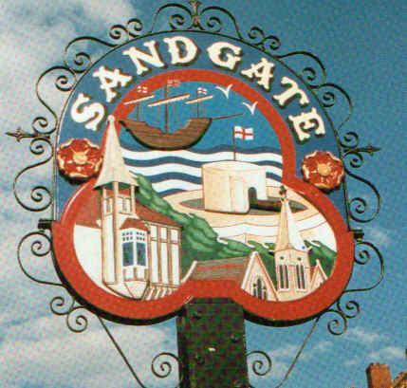

SANDGATE PARISH COUNCIL

PLANNING COMMITTEE MEETING
To be held at 6 45pm Tuesday 2nd June 2009
At
Sandgate Council Library & Offices
James Morris Court
Sandgate High Street. Sandgate.
~~~~~~~~~~~~~~~~~~~~~~~~~~~~~~~~~~~~~~~~~~~~~~~~~~~~~~~~~~

AGENDA
1. Apologies for absence

2. Declarations of Interest
Councillors present should disclose personal interests in any item on this agenda. A councillor with a personal interest must describe and give details of the interest. Unless the personal interest amounts to a prejudicial interest, he/she may participate fully in the meeting.
A prejudicial interest is one, which a member of the public with knowledge of the relevant facts, would reasonably regard as so significant that it is likely to prejudice a councillor’s judgement of the public interest. Anyone with a prejudicial interest must, unless an exception applies of a dispensation granted withdraw from the meeting room.

3 Minutes of last meeting
That the minutes of the last meeting on 14th April 2009 having been circulated be confirmed as a correct record and signed.

4. Planning Applications for discussion

Application No | Location |  | Detail | Decision
Y09/0451/SH | 35 The Crescent Sandgate |  | Erection of a single storey rear extension | Received 20 5 09  Comments by 8 6 09
Y09/0126/SH |  | Land adjoining 14 The Corniche Sandgate | Outline application for the erection of a dwelling on three floors with additional accommodation to roof | Received 21 5 09  Comments by 8 6 09
Y09/0342/SH |  | The Tower Theatre North Road Folkestone | Siting of a modular building for use as a Playschool | Received 22 5 09  Comments by 9 6 09

5 Date of the next Planning Meeting to be arranged.

