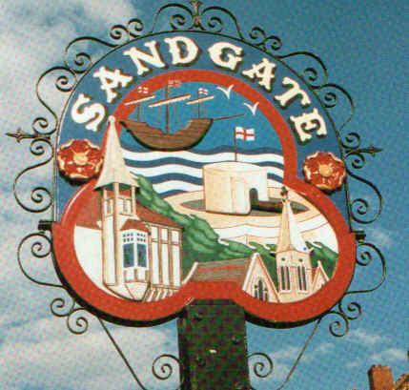

SANDGATE PARISH COUNCIL MEETING
Date: 8 December 2009. Time: 7.00pm
Venue: Sandgate Council and Library, Sandgate High Street.
To ALL MEMBERS OF SANDGATE PARISH COUNCIL
YOU ARE HEREBY SUMMONED to attend a Sandgate Council meeting on the date and at the time and place shown above. The meeting will be open to the press and public. Sandgate Parish Clerk
~~~~~~~~~~~~~~~~~~~~~~~~~~~~~~~~~~~~~~~~~~~~~~~~~~~~~~~~~~~~~~~~~~~~~~~~~~~~~~~~~~~~~~~
This is a pre-Christmas meeting, consequently we are hoping to conclude business around 8:00pm so that attendees may join in our Christmas reception, which will include snacks and drinks.
Public Questions (20 mins) (including a short presentation by Sandgate’s PCSO before the start of the meeting.)

Twenty minutes have been set-aside for the public to ask questions of the Council. Each member of the public wishing to put a question will inform the Parish Clerk at the time of their arrival at the meeting and questions will be put accordingly. Speakers will be allowed a maximum of two minutes to put his or her question. The Parish Council will endeavour to answer any question put to them within the time limit of two minutes, but may have to contact the questioner at a later date with an answer, or consider placing the matter on the agenda for the next meeting for a more lengthy discussion.
Meeting to start at 7 20pm
AGENDA
- Apologies for absence
- Declarations of Interest
Councillors and officers present should disclose personal interests in any item on this agenda. A councillor or officer with a personal interest must describe and give details of the interest. Unless the personal interest amounts to a prejudicial interest, he/she may participate fully in the meeting.
A prejudicial interest is one, which a member of the public with knowledge of the relevant facts, would reasonably regard as so significant that it is likely to prejudice a councillor’s judgement of the public interest. Anyone with a prejudicial interest must, unless an exception applies of a dispensation granted withdraw from the meeting room.
- Minutes of last meeting
- Chairman's opening remarks
- Chairman's correspondence
- Land acquisitions update
- Litter Bins update
- Newsletter [JH]
- Christmas Lights switching on – brief report
- Parish Plan + Design Statement update
- Junction Project (Military Rd/Enbrook Rd/Bybrook Field)
- Beach Cleaning
- Village Green Sign
14 East Kent Parish Highways Seminar – short report
15 Town and Parish quad-annual review
14 Environment Committee report
16 Planning Committee report
Application No | Location | Detail | Decision
Y09/1022/SH | White Lodge Cooling Lane CT20 3RE | Outline application for the erection of 9 Two Storey Dwellings with garages, Associated parking and Access | Received 11 11 09  Comments by 24 11 09  Objection  Return to SDC 24 11 09
17 Finance Committee report
18 Information items
19 Date of the next Parish Council Meeting (12 01 10)

