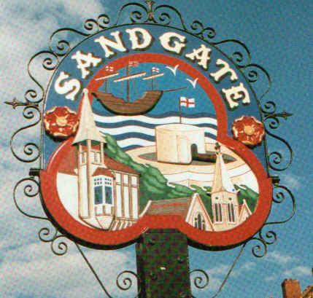

SANDGATE PARISH COUNCIL

ENVIRONMENT COMMITTEE MEETING
To be held at 7.00 pm on TUESDAY 7th July 2009

Sandgate Parish Council Library & Offices
James Morris Court
Sandgate High Street. Sandgate.

~~~~~~~~~~~~~~~~~~~~~~~~~~~~~~~~~~~~~~~~~~~~~~~~~~~~~~~~~

AGENDA

1. Apologies for absence

2. Declarations of Interest
Councillors present should disclose personal interests in any item on this agenda. A councillor with a personal interest must describe and give details of the interest. Unless the personal interest amounts to a prejudicial interest, he/she may participate fully in the meeting.
A prejudicial interest is one, which a member of the public with knowledge of the relevant facts, would reasonably regard as so significant that it is likely to prejudice a councillor’s judgement of the public interest. Anyone with a prejudicial interest must, unless an exception applies of a dispensation granted withdraw from the meeting room.

3. Minutes of last meeting That the minutes of 2nd June having been circulated, be confirmed as a correct record and signed.

4. Report from Transport Advisory Group (ZV)

5. Other Parking and Transport issues (ZV)

6. Beach: Bathing Water Quality; Signage; Inappropriate use of Gangway; Dog Fouling (ZV)

7. Parish Plan and Design Statement (ZV)

9. Plans for Sea Festival (NM)

10. Advisory and other committee reports:
Chichester Memorial Hall (JH)
Youth and Recreation (JH)
Wild Life and Open Spaces (JH)
Sandgate Society (ZV)

11. Date of the next Environment Meeting: 1st September 2009

