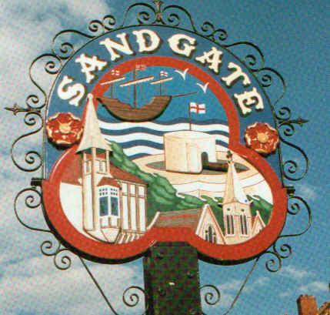

SANDGATE PARISH COUNCIL

ENVIRONMENT COMMITTEE MEETING
To be held at 7.00 pm on TUESDAY 5th May 2009

Sandgate Parish Council Library & Offices
James Morris Court
Sandgate High Street. Sandgate.

~~~~~~~~~~~~~~~~~~~~~~~~~~~~~~~~~~~~~~~~~~~~~~~~~~~~~~~~~

AGENDA

1. Apologies for absence

2. Declarations of Interest
Councillors present should disclose personal interests in any item on this agenda. A councillor with a personal interest must describe and give details of the interest. Unless the personal interest amounts to a prejudicial interest, he/she may participate fully in the meeting.
A prejudicial interest is one, which a member of the public with knowledge of the relevant facts, would reasonably regard as so significant that it is likely to prejudice a councillor’s judgement of the public interest. Anyone with a prejudicial interest must, unless an exception applies of a dispensation granted withdraw from the meeting room.

3. Minutes of last meeting That the minutes of 31st March 2009 having been circulated, be confirmed as a correct record and signed.

4. Parking and transport issues (ZV)

5. Beach: Dog Fouling and Signage (ZV)

6. New Nuclear Build at Dungeness (ZV)

7. Conservation Area Appraisal (ZV)

8. Parish Plan and Design Statement (ZV)

9. Plans for Sea Festival (NM)

10. Advisory and other committee reports:
Chichester Hall (JH)
Youth and Recreation (JH)
Wild Life and Open Spaces (JH)
Sandgate Society (ZV)

11. Date of the next Environment Meeting: 2nd June 2009

