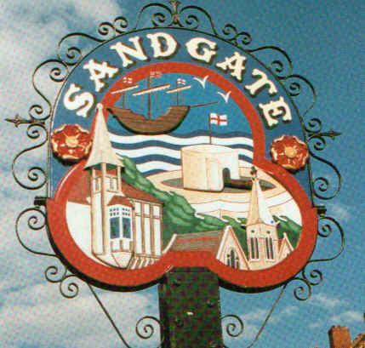

SANDGATE PARISH COUNCIL

ENVIRONMENT COMMITTEE MEETING
To be held at 7.00 pm on TUESDAY 3rd February 2009

Sandgate Parish Council Library & Offices
James Morris Court
Sandgate High Street. Sandgate.

~~~~~~~~~~~~~~~~~~~~~~~~~~~~~~~~~~~~~~~~~~~~~~~~~~~~~~~~~

AGENDA

1. Apologies for absence

2. Declarations of Interest
Councillors present should disclose personal interests in any item on this agenda. A councillor with a personal interest must describe and give details of the interest. Unless the personal interest amounts to a prejudicial interest, he/she may participate fully in the meeting.
A prejudicial interest is one, which a member of the public with knowledge of the relevant facts, would reasonably regard as so significant that it is likely to prejudice a councillor’s judgement of the public interest. Anyone with a prejudicial interest must, unless an exception applies of a dispensation granted withdraw from the meeting room.

3. Minutes of last meeting That the minutes of 6th January 2009 having been circulated, be confirmed as a correct record and signed.

4. Parking and transport issues (ZV, MF, SP)

5. Beach: Dog Fouling and Signage (ZV)

6. Parish Plan and Design Statement (JH)

7. Review of celebrations for 200th Anniversary of Sir John Moore’s Death (JH, ZV)

8. Advisory and other committee reports:
Public Amenities including land acquisition (GB)
Chichester Hall (JH, RD)
Youth and Recreation (JH)
Wild Life and Open Spaces (JH)
Sandgate Society (ZV)

9. Date of the next Environment Meeting: 3rd March 2009

