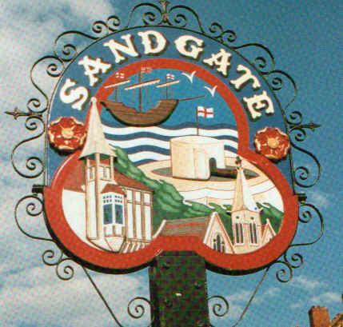

SANDGATE PARISH COUNCIL

ENVIRONMENT COMMITTEE MEETING
To be held at 7.00 pm on TUESDAY 1st December 2009

Sandgate Parish Council Library & Offices
James Morris Court
Sandgate High Street. Sandgate.

~~~~~~~~~~~~~~~~~~~~~~~~~~~~~~~~~~~~~~~~~~~~~~~~~~~~~~~~~

AGENDA

1. Apologies for absence

2. Declarations of Interest
Councillors present should disclose personal interests in any item on this agenda. A councillor with a personal interest must describe and give details of the interest. Unless the personal interest amounts to a prejudicial interest, he/she may participate fully in the meeting.
A prejudicial interest is one, which a member of the public with knowledge of the relevant facts, would reasonably regard as so significant that it is likely to prejudice a councillor’s judgement of the public interest. Anyone with a prejudicial interest must, unless an exception applies of a dispensation granted withdraw from the meeting room.

- Minutes of last meeting That the minutes of 3rd November having been circulated, be confirmed as a correct record and signed.

- Parking and Transport issues: Report from meeting with Alan Lague, SDC and correspondence with Cllr Robert Bliss, SDC (ZV); meeting with Folkestone School for Girls (ZV); meeting with Joy Evans, Saga (ZV); Community Speed Watch (ZV, SP, AR); next meeting with Kent Highway Services (ZV)

- Beach: Bathing Water Quality meeting with Environment Agency (ZV); Signage (ZV); Cleaning Rota and meeting with Graham Lawes and Kelly Finch, SDC (ZV)

- Report on other Environment issues (NB)

7. Parish Plan and Design Statement (ZV)

8. Advisory and other committee reports:
Chichester Memorial Hall (JH, RD, ZV)
Sandgate Society (ZV)

9 Date of the next Environment Meeting: 2nd February 2009

