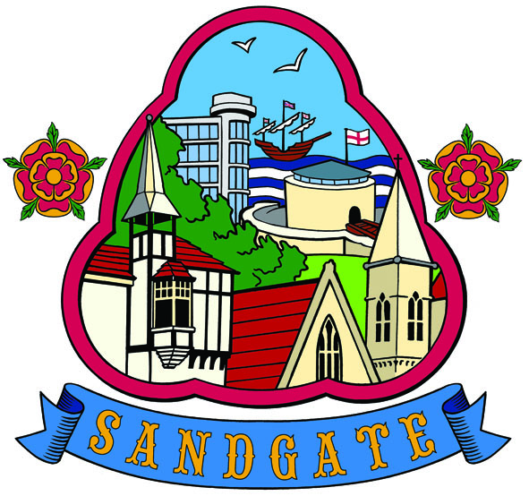

SANDGATE PARISH COUNCIL MEETING
Date: 9th March 2010 Time: 7.00pm
Venue: Sandgate Council and Library, Sandgate High Street.
To ALL MEMBERS OF SANDGATE PARISH COUNCIL

YOU ARE HEREBY SUMMONED to attend a Sandgate Council meeting on the date and at the time and place shown above. The meeting will be open to the press and public. Sandgate Parish Clerk
~~~~~~~~~~~~~~~~~~~~~~~~~~~~~~~~~~~~~~~~~~~~~~~~~~~~~~~~~~~~~~~~~~~~~~~~~~~~~~~~~~~~~~~
Public Questions (20 mins) (including a short presentation by Sandgate’s PCSO before the start of the meeting.)

Twenty minutes have been set-aside for the public to ask questions of the Council. Each member of the public wishing to put a question will inform the Parish Clerk at the time of their arrival at the meeting and questions will be put accordingly. Speakers will be allowed a maximum of two minutes to put his or her question. The Parish Council will endeavour to answer any question put to them within the time limit of two minutes, but may have to contact the questioner at a later date with an answer, or consider placing the matter on the agenda for the next meeting for a more lengthy discussion.

AGENDA

- Apologies for absence
- Declarations of Interest
Councillors and officers present should disclose personal interests in any item on this agenda. A councillor or officer with a personal interest must describe and give details of the interest. Unless the personal interest amounts to a prejudicial interest, he/she may participate fully in the meeting.
A prejudicial interest is one which a member of the public with knowledge of the relevant facts would reasonably regard as so significant that it is likely to prejudice a councillor’s judgment of the public interest. Anyone with a prejudicial interest must, unless an exception applies of a dispensation granted, withdraw from the meeting room.
- Minutes of last meeting
- Chairman's opening remarks
- Chairman's correspondence
- Yellow lines Military Rd/Bybrook/Enbrook extra costs
- Interreg funding
- Village sign budget
- Parish funding for community project proposals
- Litter Bins update
- Planters and Hanging Baskets
- Newsletter [JH]
- Parish Plan + Design Statement update
- Beach Cleaning
- Recreation Ground Amenities funding (JH)
- Business Forum
- Sandgate tourism
- Library update
- Children’s Creative Writing prizes
- Craft Club funding
- Planning Committee report
- Finance Report
- Information items
- Date of the next Parish Council Meeting (13 04 10)

