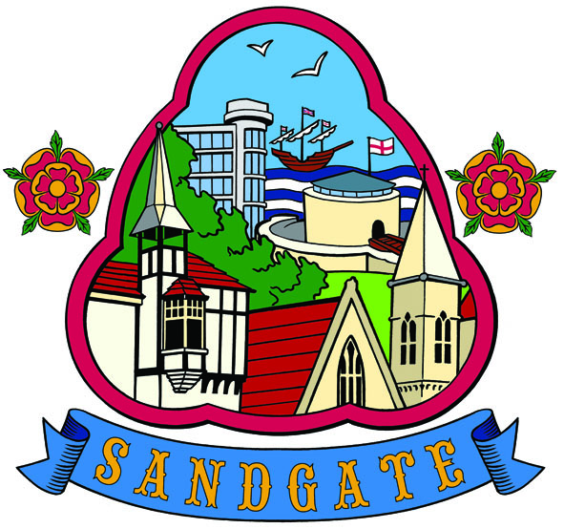

SANDGATE ANNUAL PARISH MEETING

Minutes of the meeting held on 11th May 2010 - at 7 30pm
In the Sandgate Council Library & Offices, Sandgate High Street, Sandgate.
~~~~~~~~~~~~~~~~~~~~~~~~~~~~~~~~~~~~~~~~~~~~~~~~~~~~~~~~~~~~~~~~~~~~~~~~~~~~~~~~~~~~~~~~~~~~~~
Present: Chairman Cllr G Boot
Cllrs. S Boot, N Bliss, S Prater, M Fitch,
Z Varian, S Whiffin, R Dixon, A Rimmer and J Holben
Parish Clerk Mrs G Baker
~~~~~~~~~~~~~~~~~~~~~~~~~~~~~~~~~~~~~~~~~~~~~~~~~~~~~~~~~~~~~~~~~~~~~~~~~~~~~~~~~~~~~~~
The Chairman opened the meeting at 7.30pm. There were 14 members of the public in attendance.

1. Apologies for absence - J Hartman-Jemmett

2 Acceptance of the Minutes of the Annual Parish Meeting 2009
Proposed by Cllr M Fitch, seconded by Cllr J Holben and agreed unanimously

3 Chairman’s Welcome and Yearly Overview
The Chairman welcomed everyone to the meeting and introduced the guest speaker, Mr Reg Turnill. He then gave a brief overview of the year and indicated that this was a meeting where the public were able to participate and ask any questions that they wished of the Council. He indicated that refreshments and drinks were available to all attendees at the end of the meeting and thanked Cllr S Boot for preparing the same. He expressed his gratitude for the work done by fellow councillors and the Clerk over the preceding year.

4 Guest Speaker - H G Wells Festival
Mr Reg Turnill gave a brief talk regarding the HG Wells Festival 2009, going on to say that the second HG Wells Festival would be taking place in September 2010. There will be another Short Story Competition: this would require a handwritten 5000 words of what life is like for ordinary people, working or retired, in the second decade of the 21st century. - 1st prize £1000 age 25 or less. 2nd prize £250 for 26 years plus. An event dinner to be held in Sandgate later in the year.

5 Public participation and questions
1) Coastal Park money - answered by Cllr G Boot.
2) Shingle on the maintenance gangway - answered by Cllr Z Varian

6 Any information items - None

7 Date of the next Annual Parish Meeting 10th May 2011

The public were then invited to partake in light refreshments.

The meeting closed at 8.10pm

Chairman of Council ..…………………………… Date ……………

