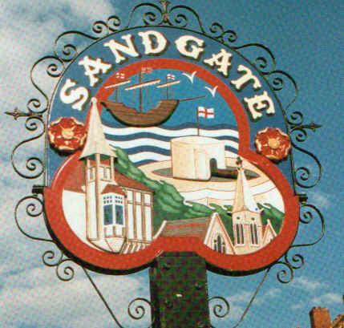

SANDGATE ANNUAL PARISH MEETING

Minutes of the meeting held on 12th May 2009 at 7 30pm
In the Sandgate Council Library & Offices, Sandgate High Street, Sandgate.
~~~~~~~~~~~~~~~~~~~~~~~~~~~~~~~~~~~~~~~~~~~~~~~~~~~~~~~~~~~~~~~~~~~~~~~~~~~~~~~~~~~~~~~~~~~~~~
Present: Chairman Cllr G Boot
Cllrs. S Boot, N Bliss J Hartman-Jemmett, S Prater, M Fitch,
Z Varian, S Whiffin, R Dixon and J Holben
Parish Clerk Mrs G Baker
~~~~~~~~~~~~~~~~~~~~~~~~~~~~~~~~~~~~~~~~~~~~~~~~~~~~~~~~~~~~~~~~~~~~~~~~~~~~~~~~~~~~~~~
Public Questions (20 mins) (PCSOs . gave a short presentation, update and answered public questions).
~~~~~~~~~~~~~~~~~~~~~~~~~~~~~~~~~~~~~~~~~~~~~~~~~~~~~~~~~~~~~~~~~~~~~~
The Chairman opened the meeting at 7.30pm. There were 17 members of the public in attendance.
1. Apologies for absence - Non received
2 Acceptance of the Minutes of the Annual Parish Meeting 2008
Proposed by Cllr M Fitch, seconded by Cllr J Hartman-Jemmett and agreed unanimously

3 Chairman’s Welcome and Yearly Overview
The Chairman remarked that the Councillors had worked well and the community of Sandgate were working well together. The Parish Pole had put the parish back to a Parish status.
Events etc were
Freedom to the Ghurkhas which was a very enjoyable community event.
The Chichester Hall a valuable community asset was now under a new committee trust and repairs were under way. An AGM to appoint new members was imminent.
Parish Plan and Design Statement was making headway.
The Sandgate Conservation Area had now also been extended.
Improvements regarding dilapidated building were being made.
The Sea festival had been and great success.
Planning Issuers were represented well.
Traffic, Parking issues are constantly being reviewed.
200 Sir John Moore memorial went well.
Acquisition of Village Green, Military Recreation Ground, Wilberforce Green etc. were well on there way.
PCSO was working well with the community.
Wild Life and Open Spaces and Youth engagement was going well.
RRRA, Twinning Ass and Sandgate Soc were all working well in the community.
Litter Pick, daffodil planting, Christmas lights, beach cleaning had enhanced Sandgate.

The precept had remained the same and accounts had been balanced with a good surplus.

Thanks were given to the Councillors and Clerk.

4 Guest Speaker Step Short presentation - Charles Fair and Terry Begent gave a talk and presentation on the Road of Remembrance in Folkestone and the importance of this to many people who have relatives who used Folkestone as a transit port during the World Wars. They also stressed the importance of the many military historic sites we have, not only in the greater Folkestone area but Sandgate in particular, and how in France these are attracting substantial tourist revenue.

5 Public participation and questions
1 Question regarding Castle Road Cark – Cllr G Boot answered saying negotiations were still in progress and he also thanked the residents for the petition which had been handed in at an earlier meeting
2 Question regarding rate charges for Sandgate residents – Cllr G Boot answered saying the part allocated for the Folkestone Parks and Pleasure Gardens was still under discussion with Folkestone Town Council and Shepway District Council.
3 Question regarding the opening times of the public toilets – this would be followed up with SDC
4 Question regarding land near Devonshire Terrace – Cllr Z Varian and Cllr R Dixon will follow this up.
5 Question regarding the Norfolk Car Park –Cllr G Boot answered.

6 Any information items
22 Date of the next Annual Parish Meeting 11th May 2010

The meeting closed at 9 pm
Chairman of Council ..…………………………… Date ………………
Cllr G Boot

