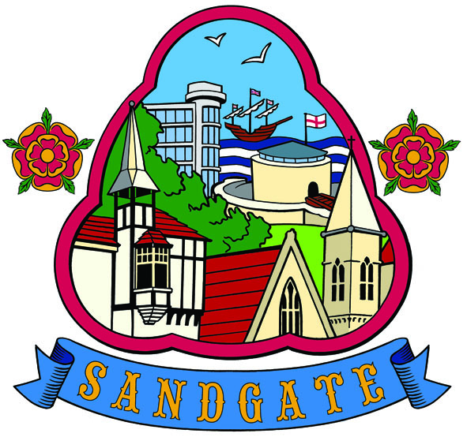
SANDGATE PARISH COUNCIL

Minutes of an Environment Committee Meeting held on
Tuesday 1st March 2011 at 7.00pm
~~~~~~~~~~~~~~~~~~~~~~~~~~~~~~~~~~~~~~~~~~~~~~~~~~~~~~~~~~~~~~~~~
Present: Chairman Cllr Z Varian
Councillors N Bliss, A Rimmer, S Boot and R Dixon

Parish Clerk G Baker
~~~~~~~~~~~~~~~~~~~~~~~~~~~~~~~~~~~~~~~~~~~~~~~~~~~~~~~~~~~~~~~~~~~
The meeting opened at 7.00pm
- Apologies for absence received from Cllrs: G Boot, and S Prater

2. Declarations of Interest - There were no declarations of interest.
Councillors and Officers present should disclose personal interests in any item on this agenda. A councillor or Officer with a personal interest must describe and give details of the interest. Unless the personal interest amounts to a prejudicial interest, he/she may participate fully in the meeting.
A prejudicial interest is one, which a member of the public with knowledge of the relevant facts, would reasonably regard as so significant that it is likely to prejudice a councillor’s judgement of the public interest. Anyone with a prejudicial interest must, unless an exception applies of a dispensation granted withdraw from the meeting room.

3. Minutes of last meeting - That the minutes of 1st February 2011 having been circulated were confirmed and signed. Proposed by Cllr N Bliss, seconded by Cllr S Boot and agreed unanimously.

4 “Respect Sandgate” campaign (ZV) There was unanimous agreement to adopt these proposals. Actions discussed and agreed per attached document. Cllr Z Varian to follow up with Graham Lawes.

5 Parking and Transport issues:
Community Speed Watch (Annual Return) Cllr A Rimmer to arrange future sessions.
Parking in Sandgate (ZV) Cllr Z Varian is liaising with Cllr Robert Bliss to get new ticketing for Castle Road car park to enable businesses to reimburse customer parking. The new parking spaces are subject to consultation process, which is yet to get underway.
Gas Main Works (ZV) works are proceeding well with anticipated completion at the end of May.
HGV’s in Radnor Cliff Crescent (ZV) Cllrs agreed unanimously to support Cllr Roland Tolputt’s campaign to get signage installed to prevent lorries using Radnor Cliff Crescent.
Saga and Enbrook: Consultation update (ZV) Cllr Varian deplored the time it has taken to get consultation process under way particularly given the increase in dangerous incidents in the Enbrook area. Representations have been made to SDC by councillors and Enbrook residents to get matters underway with all possible speed.

6 Beach: Blue Flag application – Cllr Varian will call meeting of Beach Management Committee before May. The Community Landscaping Project will be managed under its auspices.
Public Convenience - progress report (ZV) Cllr Robert Bliss has indicated that works should be completed by July.

8 Advisory and other committee reports
Sandgate Soc (ZV) Cllrs noted AGM is on 12th March 2011 in Chichester Memorial Hall and Clerk will assist with celebration of the working life of Fred Moore.
Date of the next Environment Meeting: Tuesday 5th April 2011
The meeting closed at 8 10 pm

Signed by the Chairman Environment Committee…………………………………Date………………

