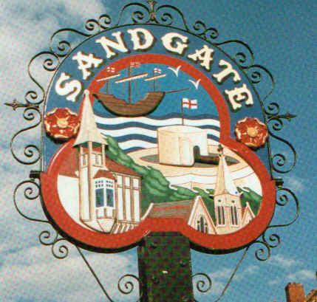

SANDGATE PARISH COUNCIL

ENVIRONMENT COMMITTEE MEETING
To be held at 7.00 pm on TUESDAY 1st February 2011

Sandgate Parish Council Library & Offices
James Morris Court
Sandgate High Street. Sandgate.

~~~~~~~~~~~~~~~~~~~~~~~~~~~~~~~~~~~~~~~~~~~~~~~~~~~~~~~~~

AGENDA

1. Apologies for absence

2. Declarations of Interest
Councillors present should disclose personal interests in any item on this agenda. A councillor with a personal interest must describe and give details of the interest. Unless the personal interest amounts to a prejudicial interest, he/she may participate fully in the meeting.
A prejudicial interest is one, which a member of the public with knowledge of the relevant facts, would reasonably regard as so significant that it is likely to prejudice a councillor’s judgement of the public interest. Anyone with a prejudicial interest must, unless an exception applies of a dispensation granted withdraw from the meeting room.

- Minutes of last meeting That the minutes of 2nd November 2010 having been circulated, be confirmed as a correct record and signed.

- “Respect Sandgate” campaign (ZV)

- Parking and Transport issues: Reports from KHS Meeting 10th November 2010 and Stagecoach Meeting 14th January 2011 (ZV); Community Speed Watch (AR); Parking in Sandgate (ZV) Gas Main Works (ZV)

- Saga and Enbrook: Report on meeting with Alan Lague on 28th January 2011 (ZV):

- Beach: Blue Flag application – progress report (SP); Public Convenience – progress report (ZV)

- Parish Plan and Design Statement (MFS)

- Advisory and other committee reports:
Chichester Memorial Hall (JH, ZV)
Sandgate Society (ZV)

Date of the next Environment Meeting: Tuesday 1st March 1011

