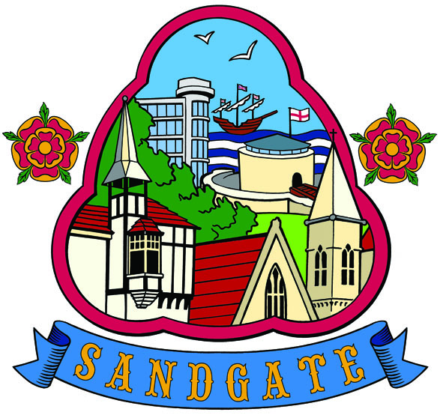

SANDGATE PARISH COUNCIL

PLANNING COMMITTEE MEETING
To be held at Tuesday 6th December 2011
At 6pm
Sandgate Council Library & Offices
James Morris Court
Sandgate High Street. Sandgate
~~~~~~~~~~~~~~~~~~~~~~~~~~~~~~~~~~~~~~~~~~~~~~~~~~~~~~~~~~

AGENDA
1. Apologies for absence

2. Declarations of Interest
Councillors present should disclose personal interests in any item on this agenda. A councillor with a personal interest must describe and give details of the interest. Unless the personal interest amounts to a prejudicial interest, he/she may participate fully in the meeting.
A prejudicial interest is one, which a member of the public with knowledge of the relevant facts, would reasonably regard as so significant that it is likely to prejudice a councillor’s judgement of the public interest. Anyone with a prejudicial interest must, unless an exception applies of a dispensation granted withdraw from the meeting room.

3. Minutes of the last meeting
That the minutes of the last meeting held on 22nd November 2011 having been circulated be confirmed as a correct record and signed.

4. Planning Applications for discussion

Y11/1092/SH | 25 Radnor Cliff  Folkestone | Conservation area consent for the demolition of existing dwelling in connection with planning application reference Y10/1049/SH | Received 18 11 11  Comments by 08 Dec 11
Y11/0914/SH | Flats 1 and 2 12 Radnor Cliff  Folkestone | Listed building consent for the installation of an internal staircase | Received 18 11 11  Comments by 09 Dec 11
Y11/1070/SH | Sir John Moore Barracks  North Road  Folkestone | Outline application for erection of two storey office building (2,295sqm floorspace) and two storey annexe to officers mess (850sqm floorspace) to accommodate 22 single bedrooms and associated access | Received 22 11 11  Comments by 14 Dec 11
Y11/1087/SH | Spanish House  Sandgate Esplanade  Sandgate | Erection of detached car port and cycle store | Received 28 11 11  Comments by 18 Dec 11

5. Update on previous planning applications

6. Terms of Reference
To agree previously circulated draft Terms of Reference for Planning Committee meetings, for approval at the next main council meeting.

7. Development of Sandgate - to discuss the need for a geo-technical report

8. Correspondence

9. Information

10. Date of the next Planning Meeting

