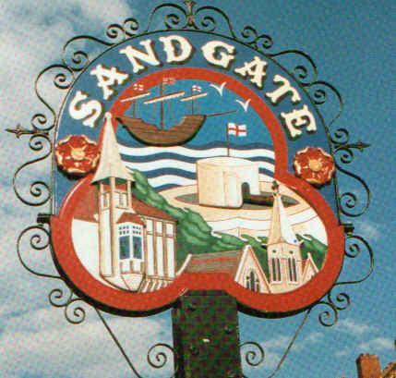

SANDGATE PARISH COUNCIL

ENVIRONMENT COMMITTEE MEETING
To be held at 7.00 pm on Tuesday 6th December 2011

Sandgate Parish Council Library & Offices
James Morris Court
Sandgate High Street, Sandgate
~~~~~~~~~~~~~~~~~~~~~~~~~~~~~~~~~~~~~~~~~~~~~~~~~~~~~~~~~

AGENDA
1. Apologies for absence

2. Declarations of Interest
Councillors present should disclose personal interests in any item on this agenda. A councillor with a personal interest must describe and give details of the interest. Unless the personal interest amounts to a prejudicial interest, he/she may participate fully in the meeting.
A prejudicial interest is one, which a member of the public with knowledge of the relevant facts, would reasonably regard as so significant that it is likely to prejudice a councillor’s judgement of the public interest. Anyone with a prejudicial interest must, unless an exception applies of a dispensation granted withdraw from the meeting room.

3. Minutes of the last meeting - that the minutes of the last meeting held on 1st November having been circulated be confirmed as a correct record and signed

4. Communications – MFS

5. Report from Transport and Parking advisory group - NG

6. Report from Beaches Advisory Group – TH

7. Report from Business and Tourism Advisory Group – TP

8. Reports on
- Chichester Memorial Hall – JH
- Christmas Lights event and evaluation - NB
- Youth and Recreation – JH
- Wild life and open spaces – links to Parish Plan and recreational facilities – JH/MFS
- Sandgate Society - MFS

9. Terms of Reference
To review and agree previously circulated draft Terms of Reference for Environment meetings, for approval at the next main council meeting

10. Information

11. Date of the next meeting 3rd January 2012

