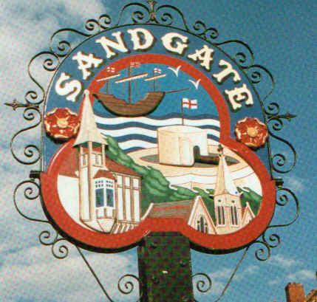

SANDGATE PARISH COUNCIL

ENVIRONMENT COMMITTEE MEETING
To be held at 7.00 pm on Tuesday 1st November 2011

Sandgate Parish Council Library & Offices
James Morris Court
Sandgate High Street, Sandgate

~~~~~~~~~~~~~~~~~~~~~~~~~~~~~~~~~~~~~~~~~~~~~~~~~~~~~~~~~

AGENDA

1. Apologies for absence

2. Declarations of Interest
Councillors present should disclose personal interests in any item on this agenda. A councillor with a personal interest must describe and give details of the interest. Unless the personal interest amounts to a prejudicial interest, he/she may participate fully in the meeting.
A prejudicial interest is one, which a member of the public with knowledge of the relevant facts, would reasonably regard as so significant that it is likely to prejudice a councillor’s judgement of the public interest. Anyone with a prejudicial interest must, unless an exception applies of a dispensation granted withdraw from the meeting room.

3. Minutes of last meeting

4. Correspondence – MFS

5. Report from Transport and Parking advisory group - NG

6. Report from Beaches Advisory Group – TH

7. Report from Business and Tourism Advisory Group – TP

8. Reports on
- Chichester Memorial Hall – JH
- Plans for Christmas Lights- NB
- Youth and Recreation – JH
- Wild life and open spaces – links to Parish Plan and recreational facilities – JH
- Sandgate Society - MFS
- Public realm designs

9. Precept for 2012/13

10. Information

11. Date of the next meeting 6th December 2011

