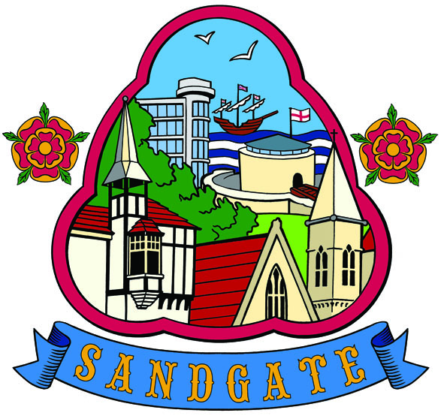
SANDGATE PARISH COUNCIL

Minutes of an Environment Committee Meeting held on
Tuesday 11^{h} October 2011 at 6.00pm
~~~~~~~~~~~~~~~~~~~~~~~~~~~~~~~~~~~~~~~~~~~~~~~~~~~~~~~~~~~~~~~~~
Present: Chairman Cllr Nigel Griffiths (acting chairman)
Councillors N Bliss, R Bliss, T Prater, L Griggs and R Grundy

Parish Clerk A Oates
~~~~~~~~~~~~~~~~~~~~~~~~~~~~~~~~~~~~~~~~~~~~~~~~~~~~~~~~~~~~~~~~~~~
The meeting opened at 6.00pm no members of the public attended

1. Vote in the Chairman - that Cllr Nigel Griffiths be voted in as the acting Chairman.

Proposed by: Cllr R Bliss
Seconded by: Cllr T Prater

2. Apologies for absence: Cllrs: M Findlay-Stone, G Fuller, T Heselden and J Holben

3. Declarations of Interest - There were no declarations of interest.

4. Minutes - The minutes of the meeting held on 6th September 2011 were submitted, approved as a correct record and signed by the Chairman.

Proposed by: Cllr T Prater
Seconded by: Cllr Leo Griggs

5. Communications - Cllr N Griffiths read out notes received from Cllr M Findlay-Stone. Additional comments noted under relevant agenda item.
5.1 Notification to Veolia for street clearing by parked cars - this has been actioned. The committee needs to monitor this.
5.2 Land adjoining 5 Radnor Cliff - Cllr N Griffiths has been monitoring the land slippage
5.3 Plaque for Dame Sheila Sherlock will go up on Friday 4th November at 3pm - all councillors welcome
5.4 Jocelyn Brook plaque will go up on 22 Radnor Cliff but waiting for agreement.

6. Report from Transport and Parking Advisory Group - Cllr N Griffiths updated the committee.
6.1 The district council has issued the draft parking strategy. It was felt that it is likely that there will be a lot of interest from Sandgate residents and businesses on this and that the strategy will change considerably after the consultation period. It is important that the parish council gets more information. It was agreed that Cllr N Griffiths would be the point of contact for the council and he will contact Bob Porter at the district council.
6.2 The council had previously been informed that there would be a release of some of the double yellow lines but this had not happened. There will be a review of all double yellow lines in the district as part of the parking strategy.
6.3 It was noted that there is a problem with parking on pavements in Enbrook Valley.

7. Report from Beaches Advisory Group
7.1 Costs for having a beach cleaner have been obtained. This was deferred to the Finance Committee for more detailed information.
7.2 Mark Hanton has been given the go-ahead for consultation drawings and design. Plans for the Public Realm works have been delivered to the Parish Clerk. It was noted that for all future contracts of work three quotes must be obtained.

8. Report from Business and Tourism Advisory Group - Cllr T Prater updated the committee.
8.1 The pet shop has moved away. This was attributed to the loss of business whilst the gas works were carried out in the village, preventing customers from being able to access the shop. When the works were completed, too many customers had gone elsewhere.
8.2 One new business has opened in the village - a computer shop.
8.3 The vacant shop which had the auction sign now appears to have been sold.
8.4 Parking is still the main issue for business.

9. Reports on
9.1 Chichester Memorial Hall – none to report.
9.2 Plans for Christmas lights - the event will take place on Saturday 26th November. Mince pies and mulled wine will be served. The Parish Clerk is liaising with Dan File at Sandgate Primary School regarding children singing; Cllr N Bliss has had one meeting with David Hebditch regarding the Rock & Roll event, which will be held the following weekend on two nights - Friday 2nd and Saturday 3rd December.
9.3 Youth and Recreation - none to report.
9.4 Wild life and open spaces – links to Parish Plan and recreational facilities - Cllr L Griggs reported on overgrown footpaths in the valley. It was agreed that Cllr Griggs would supply a list of the areas for Cllr T Prater, who will then look into ownership of these areas with the district council.
9.5 Cllr T Prater informed the committee that the large 4-5 meter high bank by No 112 in the Crescent is about to fall over. Residents in the area are working together to address the matter.
9.6 Sandgate Society - none to report
.
10. Date of the next meeting - 1st November 2011.

The meeting closed at 6.38pm

Signed by the Chairman Environment Committee…………………………………Date………………

