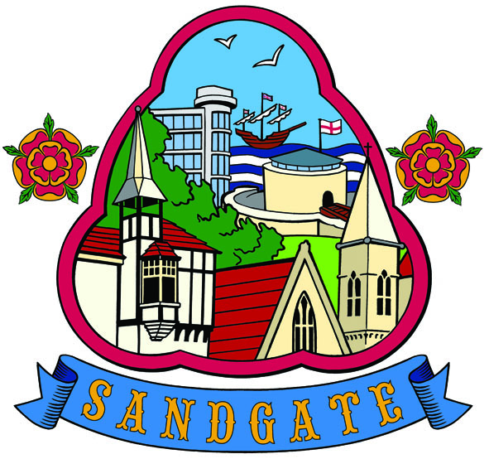

Minutes

SANDGATE PARISH COUNCIL MEETING
Date 11th October 2011. Time: 7.00pm
Venue: Sandgate Council and Library, Sandgate High Street.
~~~~~~~~~~~~~~~~~~~~~~~~~~~~~~~~~~~~~~~~~~~~~~~~~~~~~~~~~~~~~~~~~~~~~~~~~~~~~~~~~~~~~~~~~~~~~~
Present: Chairman Cllr R Bliss
Cllrs. N Bliss, M Fitch, T Heselden, L Griggs, R Grundy, N Griffiths and T Prater
Clerk Ms A Oates
~~~~~~~~~~~~~~~~~~~~~~~~~~~~~~~~~~~~~~~~~~~~~~~~~~~~~~~~~~~~~~~~~~~~~~~~~~~~~~~~~~~~~~~
PCSO D Bishop gave a short update and put questions to the council on behalf of the public. She also announced that she will cease to be PCSO for Sandgate; from 16th November it will be PCSO Lesley Jarman.

Questions
1) When will yellow lines be in place in Enbrook Valley - Cllr N Griffiths will chase this up
2) Can the public park by the bus stop where there are no yellow lines - Cllr N Griffiths will find out

~~~~~~~~~~~~~~~~~~~~~~~~~~~~~~~~~~~~~~~~~~~~~~~~~~~~~~~~~~~~~~~~~~~~~~~~~~~~~~~~~~~~~~~
The Chairman opened the meeting at 7.10pm. no members of the public attended

1. Apologies for absence
Apologies were received from Cllrs. G Fuller, J Holben and M Findlay-Stone.

2. Declarations of Interest
There were no declarations of interest.

3. Minutes of last meeting
The minutes of 13th September 2011 were confirmed as a correct record and signed by the Chairman.

Proposed by: Cllr L Griggs
Seconded by: Cllr N Griffiths
This was agreed unanimously.

4. Chairman’s opening remarks
The Chairman extended the council’s best wishes for Cllr J Holben’s speedy recovery.

5. Chairman’s correspondence
In response to the letter the Chairman had sent to the parish and town councils regarding support for Shepway tourism, replies have been received from Lyminge, Lympne and Newington Parish Councils and Hythe Town Council. The Parish Clerk was requested to send copies of the letters to Chris Kirkham, manager of Discover Folkestone, Hythe and Romney Marsh (DFHRM).

6. To confirm renewed PCSO agreement

Proposed by: Cllr T Prater
Seconded by: Cllr N Bliss
This was agreed unanimously.

7. Parish Council newsletter
It was proposed that the Parish Clerk produces a monthly/6-weekly newsletter which will mainly be distributed by email; hard copies would be available in the library.

Proposed by: Cllr R Bliss
Seconded by: Cllr T Heselden
This was agreed unanimously.

Resolved: That the Parish Clerk continues to collect email addresses from local residents and businesses and produces a newsletter to promote council business, the library and events happening in the parish and to send a request to all parish councillors to submit copy for the newsletter. It was also resolved that the Parish Clerk determines the number of printed newsletters that would be required under Quality Council status.

8. Proposed amendment to Standing Orders for the Planning Committee to reverse decisions
The Finance Committee requested that the following be included in Standing Orders:

36. (c) In the case of a request by the Planning Department to reverse a decision of the Planning Committee as a result of additional information not available at the time of the meeting at which the relevant application was discussed, the Clerk shall inform all Councillors of the request in writing as well as communicating the nature of the Committee’s previous objections to the planning application. Any move to reverse a decision of the Planning Committee shall be subject to the provisions of paragraphs (a) and (b) of this Order. Any planning application submitted under a new application number shall not be subject to the provisions of paragraphs (a) and (b) of this Order.

Proposed by: Cllr N Bliss
Seconded by: Cllr L Griggs
This was agreed unanimously.

Resolved: That the Parish Clerk will insert the amendment into Standing Orders.

9. Sport England’s Inspired Facilities initiative
The Chairman read out a brief report prepared by Cllr J Holben concerning Sport England’s aims to improve facility design and raise standards and that the councillor is exploring the potential for the council to benefit from the Sport England initiative. The comments were noted.

10. The Queen’s Diamond Jubilee
There were queries as to what celebration events are being planned across the Shepway district and in other districts in east Kent. The Parish Clerk was requested to contact Chris Kirkham of DFHRM to find out if any celebrations are being planned for Folkestone and to ascertain if Sandgate Society and Shepway District Council have any plans and to make these plans known at the next council meeting. The DCMS will be co-ordinating official events during the first weekend in June and is encouraging districts across the country to light beacons or bonfires on Monday 4th June, which will be a Public Holiday. This was referred to the Environment Committee.

11. Additional rubbish bins
There was a discussion as to whether two additional bins should be sited in Enbrook Valley. Councillors felt that this was dependent on whether the district council will collect the rubbish within the existing collection service. Also the parish council’s stock of bins needs to be assessed. This matter was referred to the Finance Committee.

12. Environment Committee report
The Chairman read out an update supplied by the Environment Committee Chairman, Cllr M Findlay-Stone. There was an option to employ someone re beach cleaning but this had been referred to the Finance Committee at the earlier Environment Committee meeting. Cllr N Griffiths is looking into the matter of the land slippage at 5 Radnor Cliff and the lack of submitted plans to the private building control contractors re water drainage and foundations. Plans for the Christmas Rock and Roll event were under way. Mark Hanton has been given the go-ahead for consultation drawings and design for Granville Parade toilets. Two more plaques will be put up – one for Dame Sheila Sherlock and one for Jocelyn Brook.

13. Advisory Group report (Business, Traffic and Parking)
An update on the broadband initiative previously received from David Cowell was read out and the comments noted.

14. Planning Committee report
Planning applications discussed since the last council meeting were reported and noted. The Parish Clerk was requested to contact the planning department at the district council to find out if the planning application for Y11/0825/SH has been passed.

15. Date of the next Council Meeting
This will be Tuesday 8th November 2011.

The meeting closed at 7.55pm

Chairman of Council ..…………………………… Date ……………….......

